Chapter1: INTRODUCTION

*by* Soni Jain

**Submission date:** 05-May-2022 07:47PM (UTC+0530)

**Submission ID:** 1828983534

**File name:** PLagcheck_Major_Report_SSA.docx (49.29K)

**Word count:** 7800

**Character count:** 40688

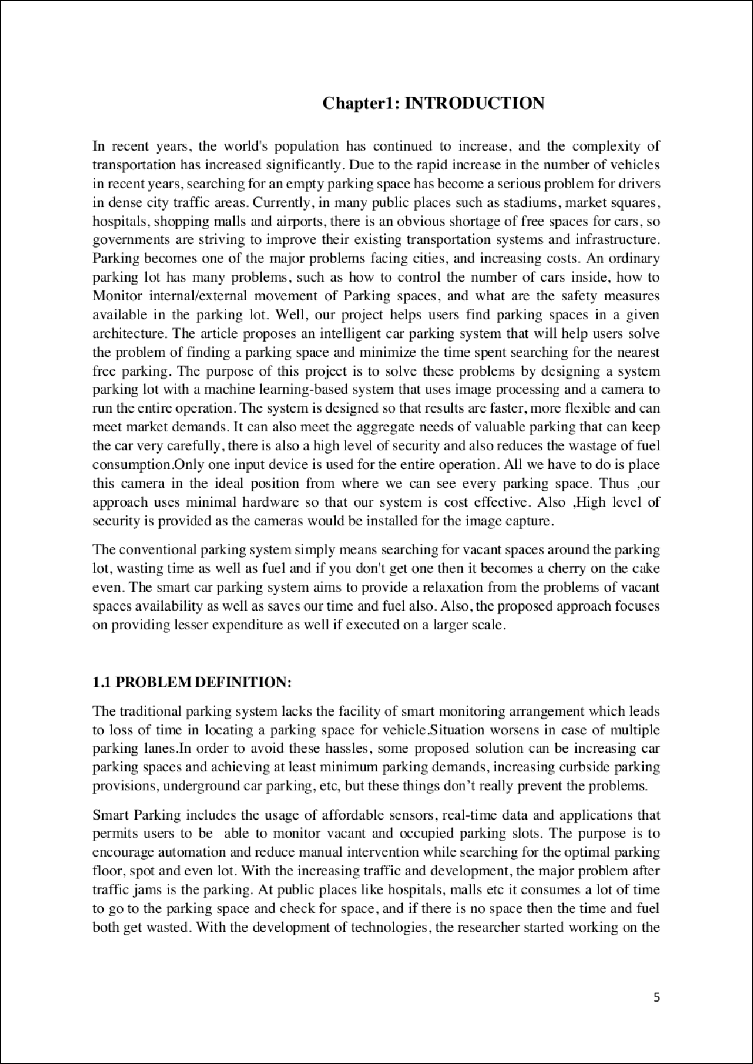

29

4

12

4

31

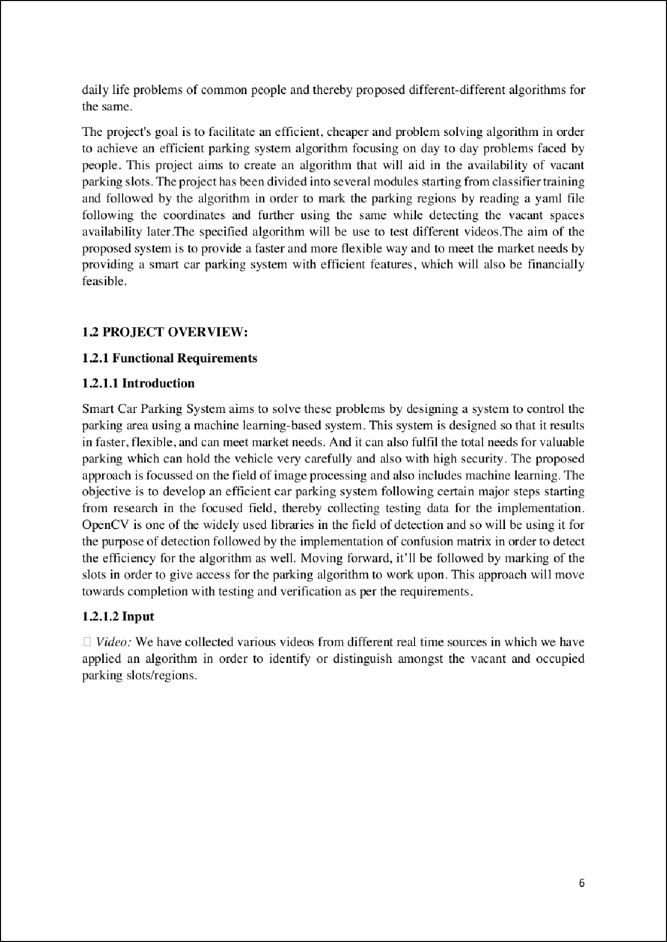

4

20

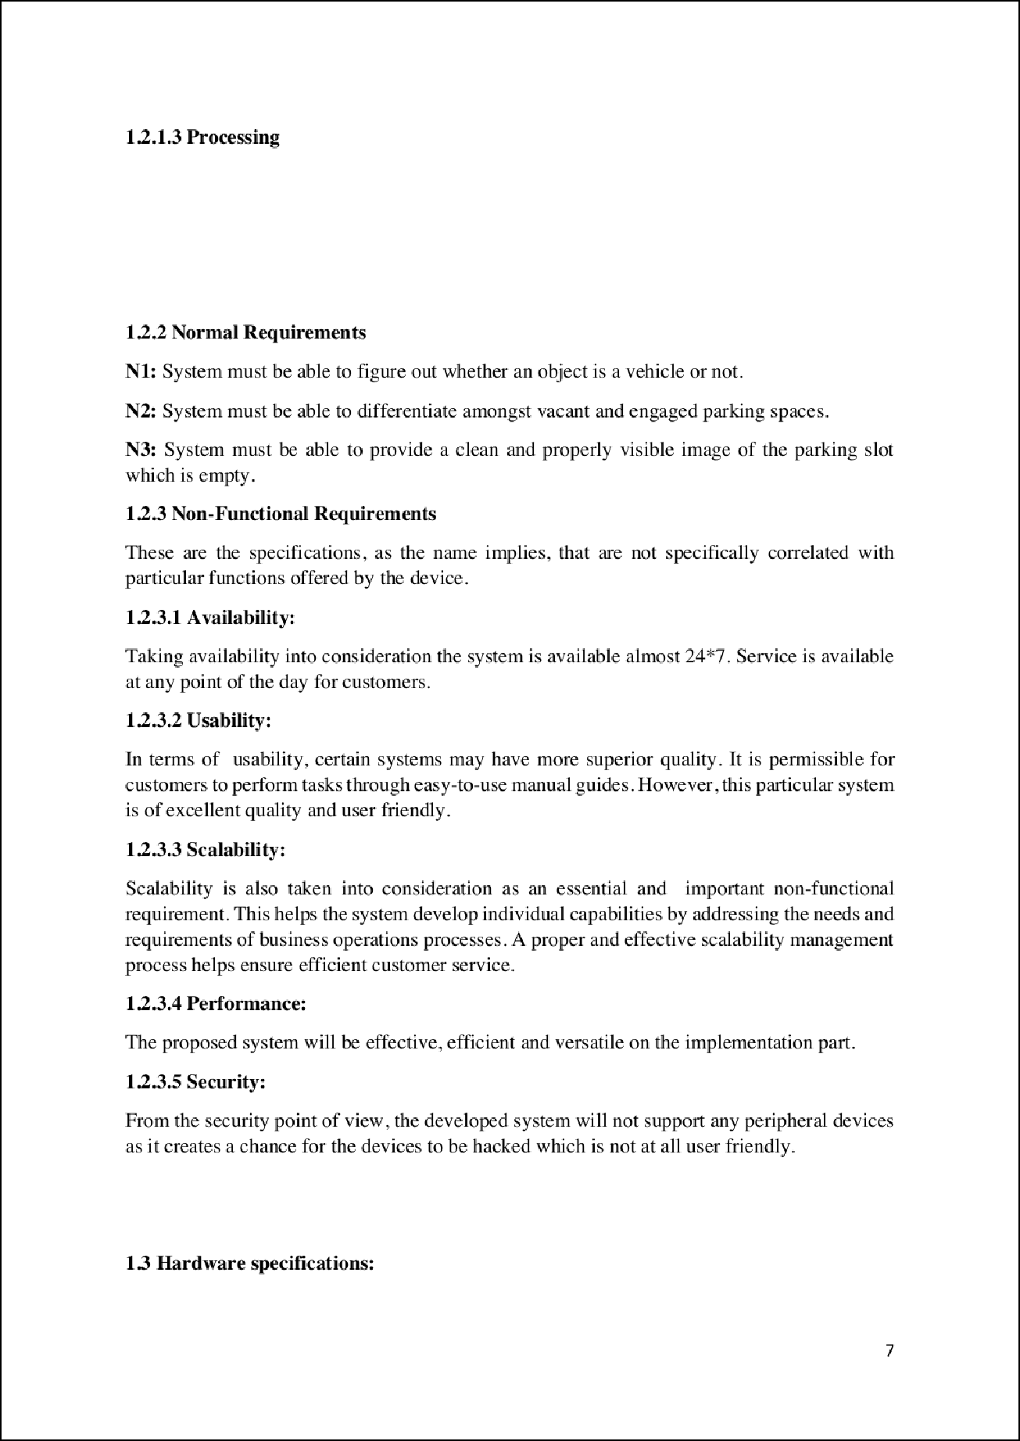

1

1

1

1

1

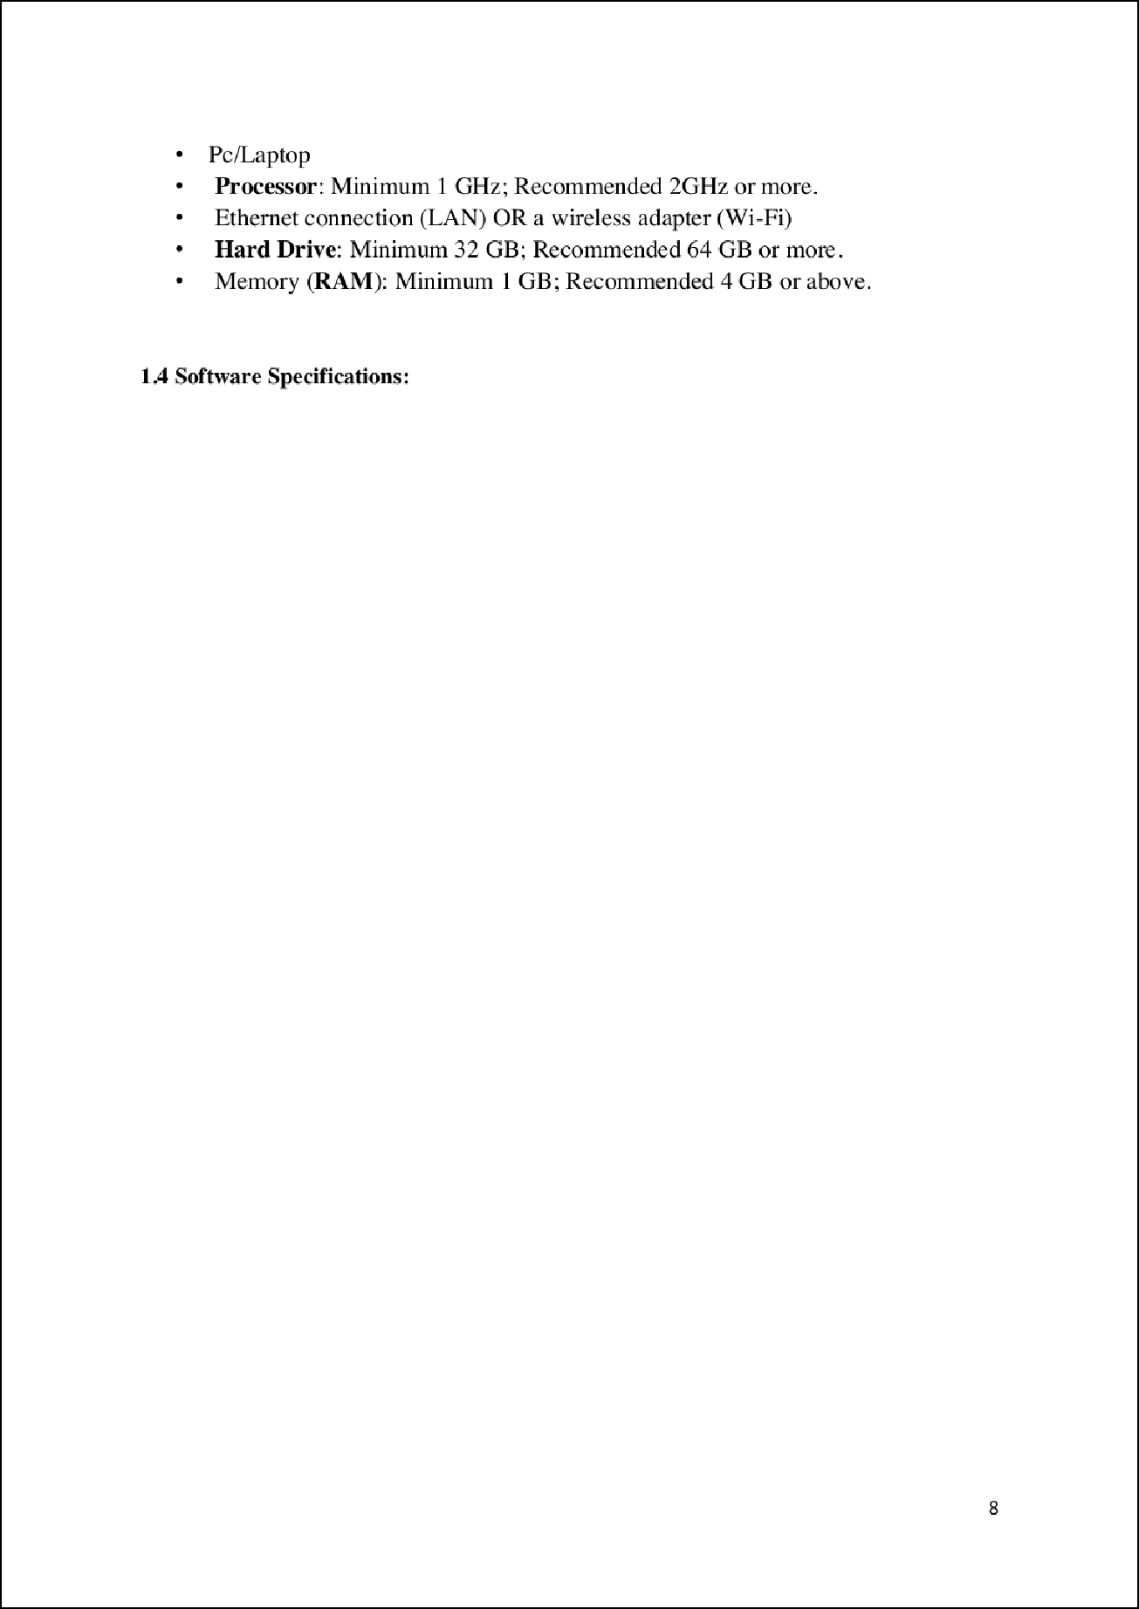

6

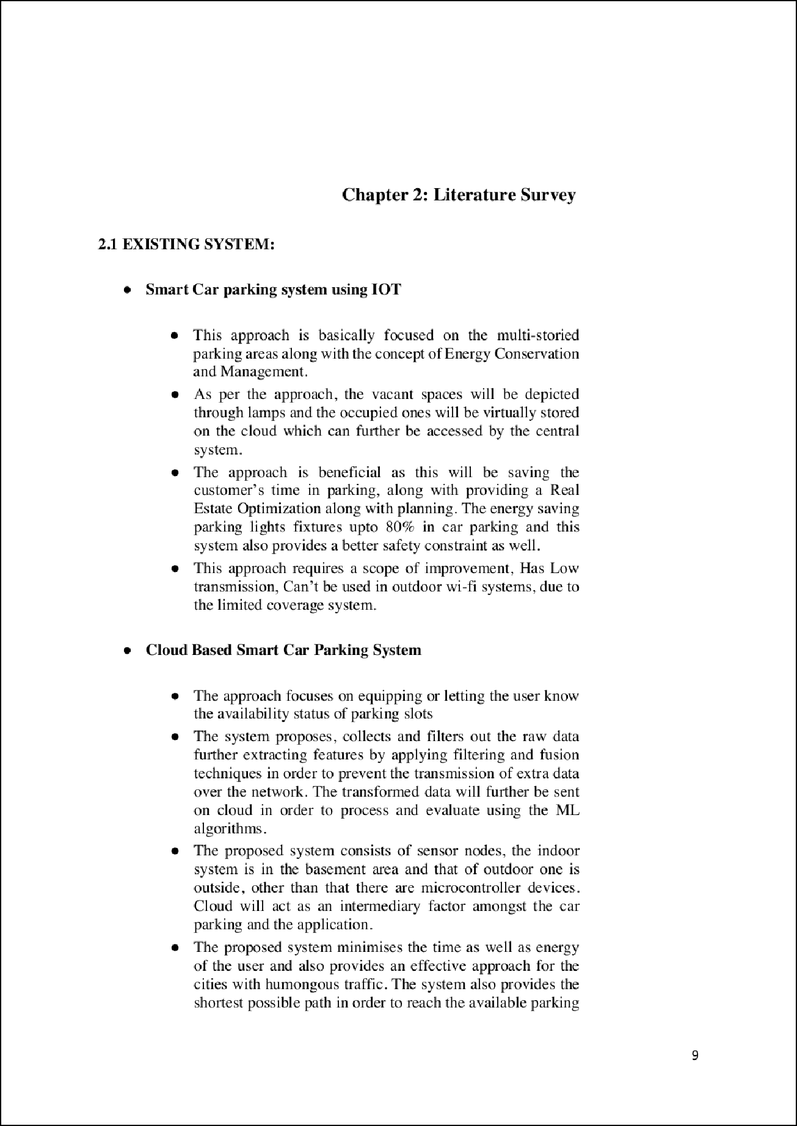

34

19

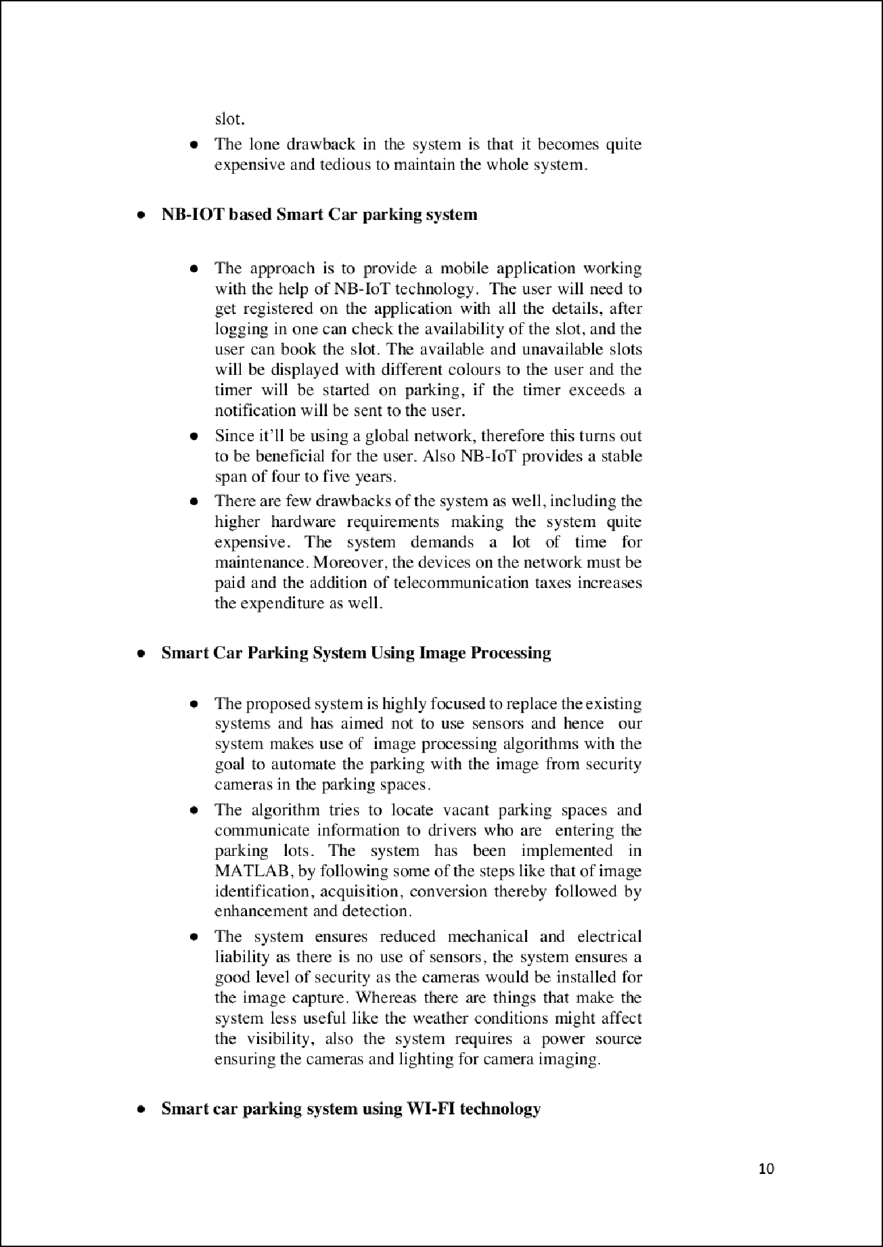

30

32

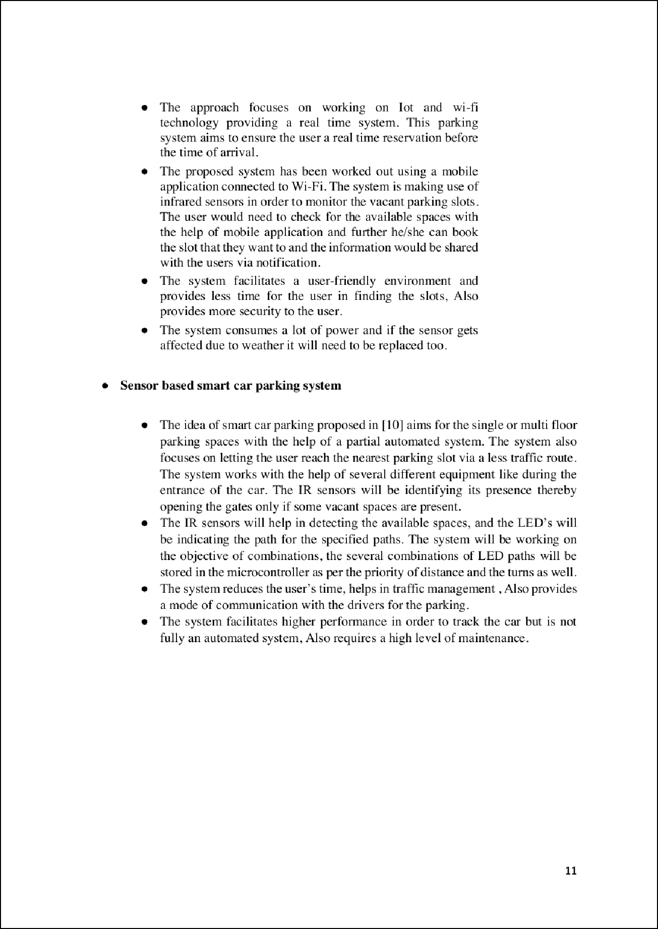

33

27

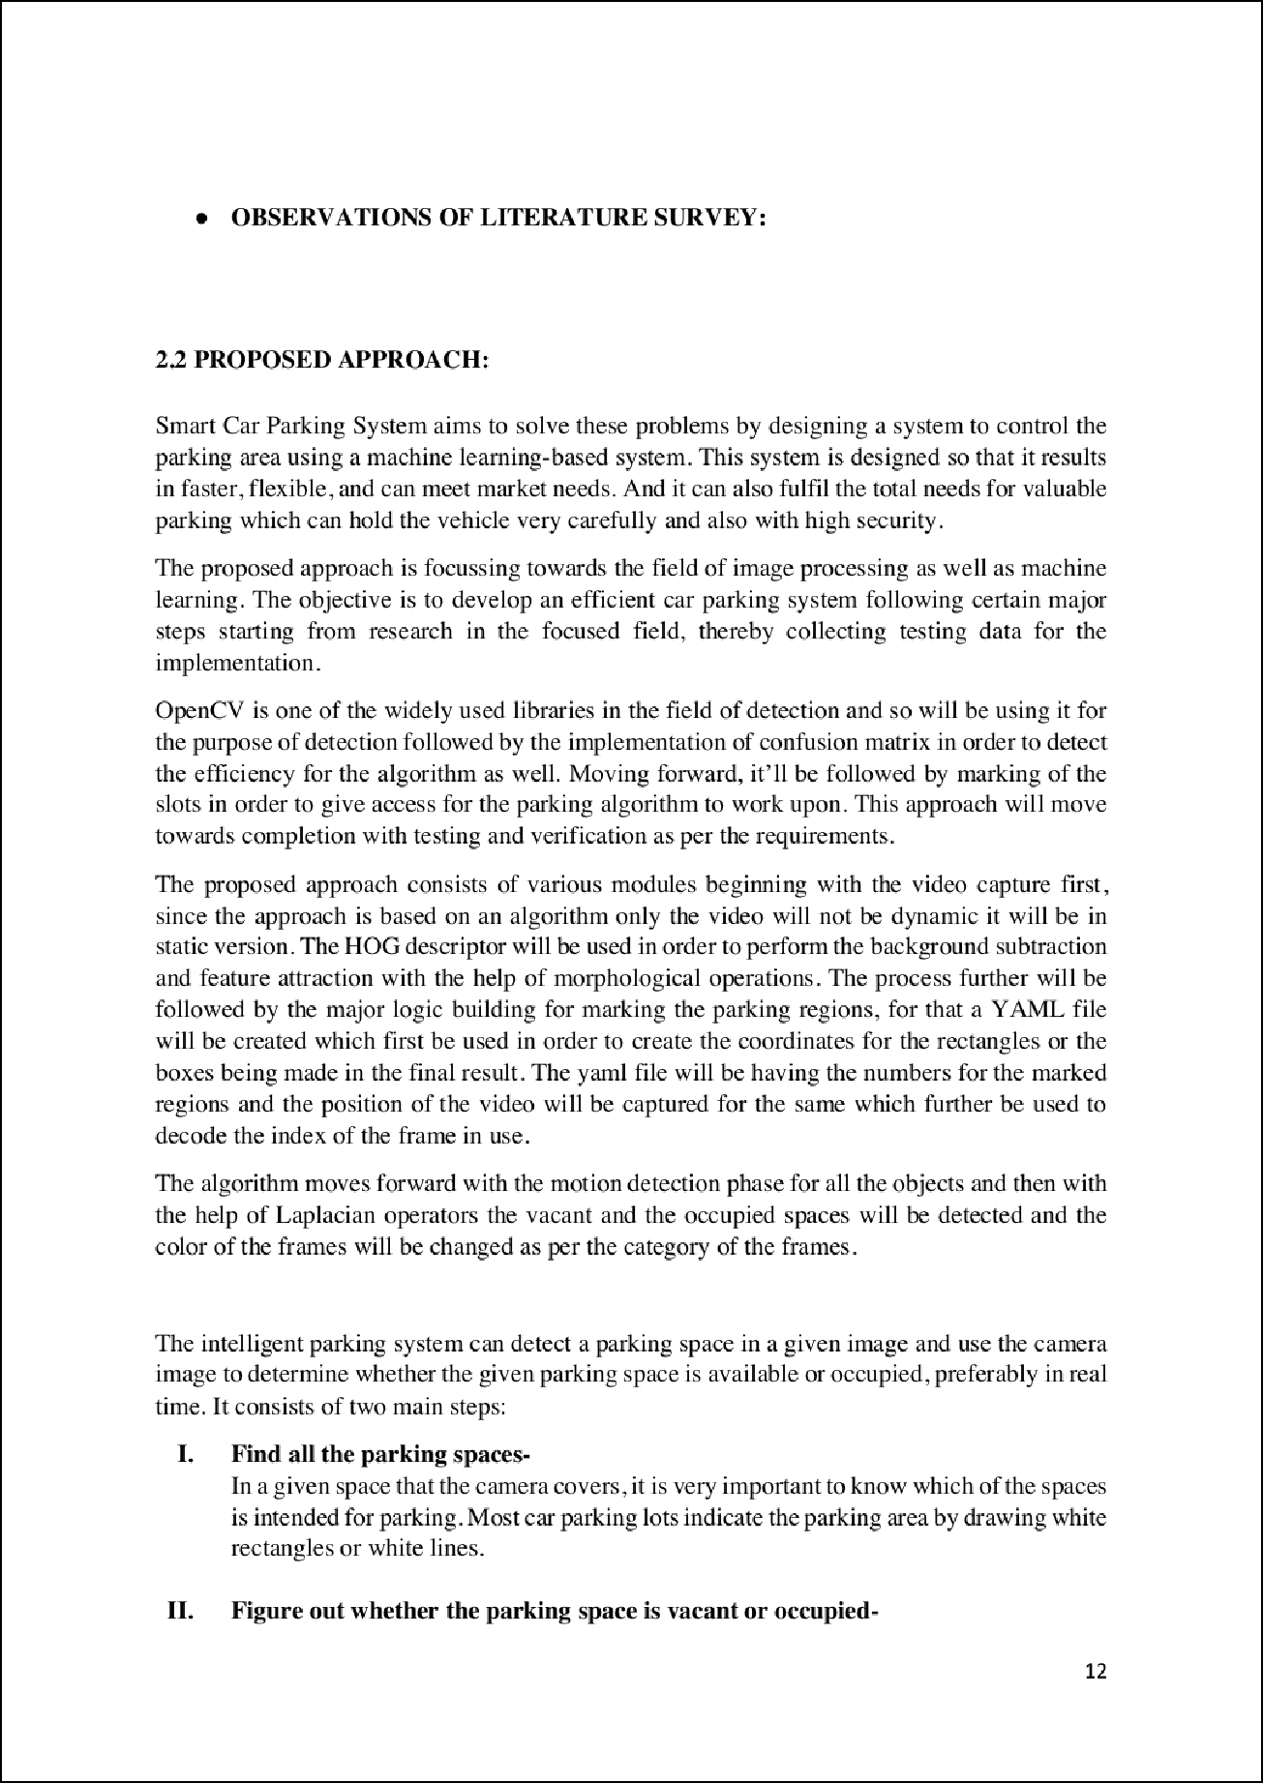

4

20

3

3

3

3

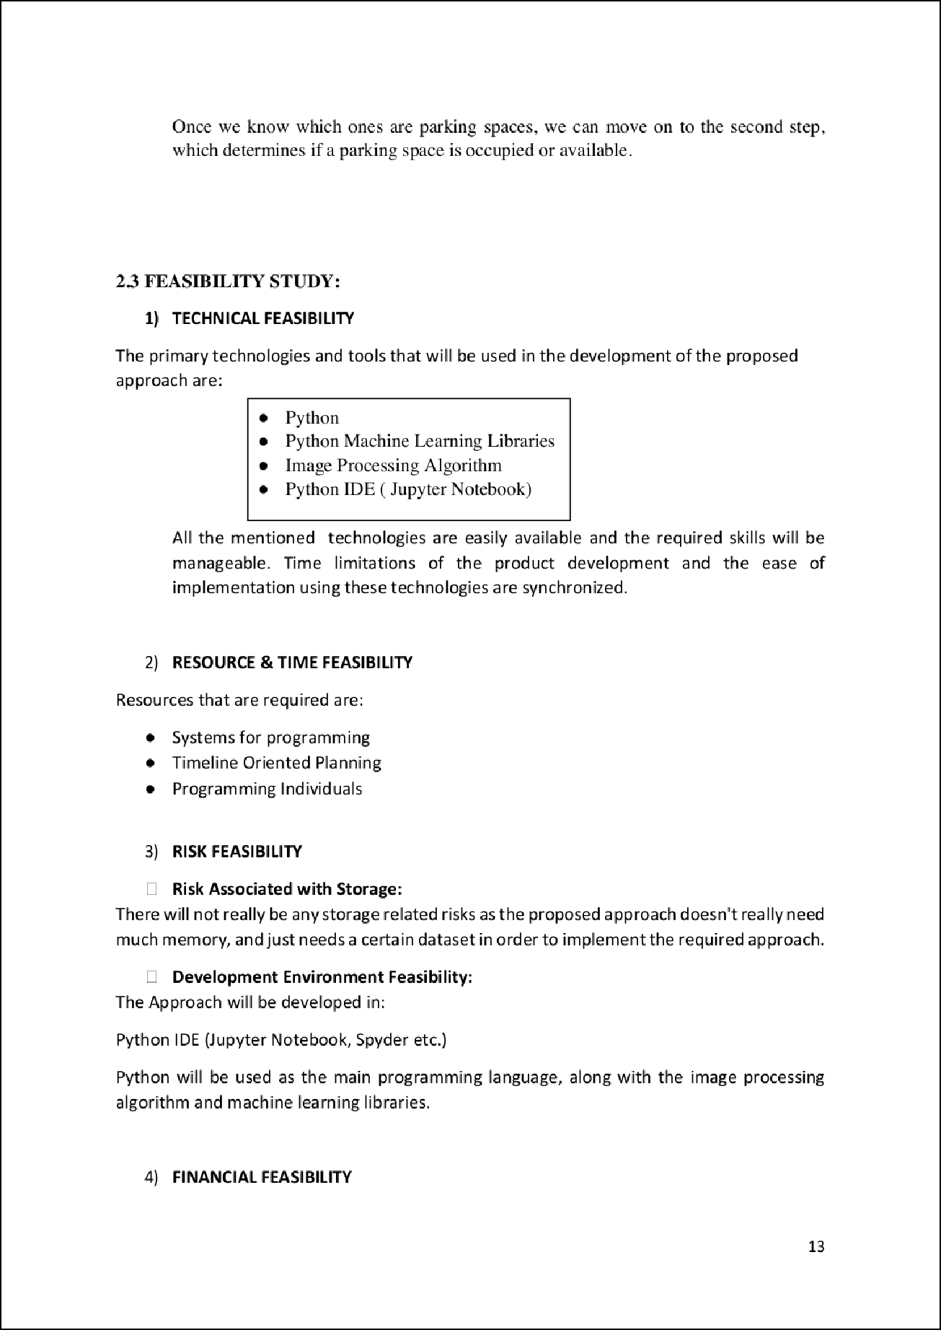

11

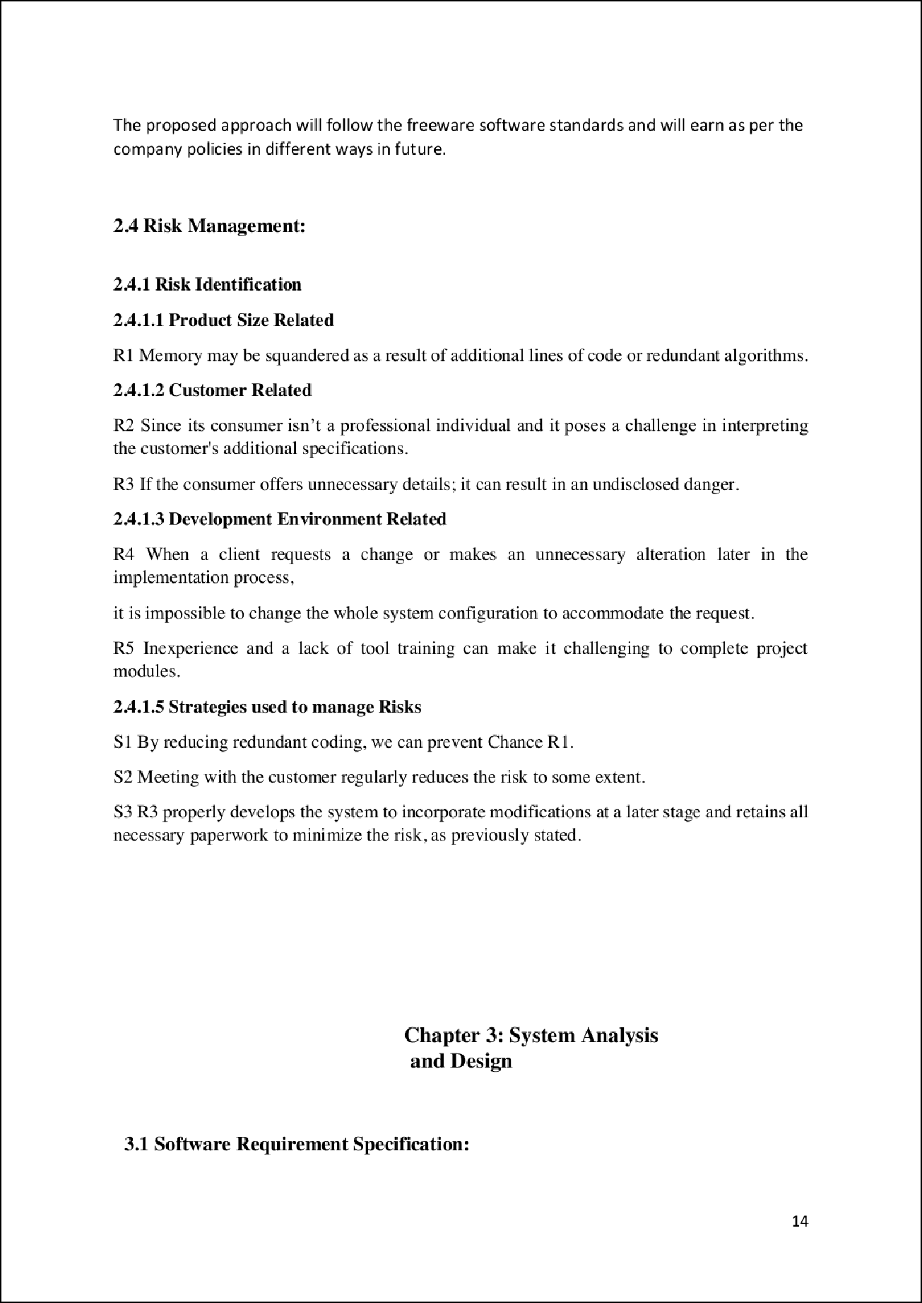

26

5

23

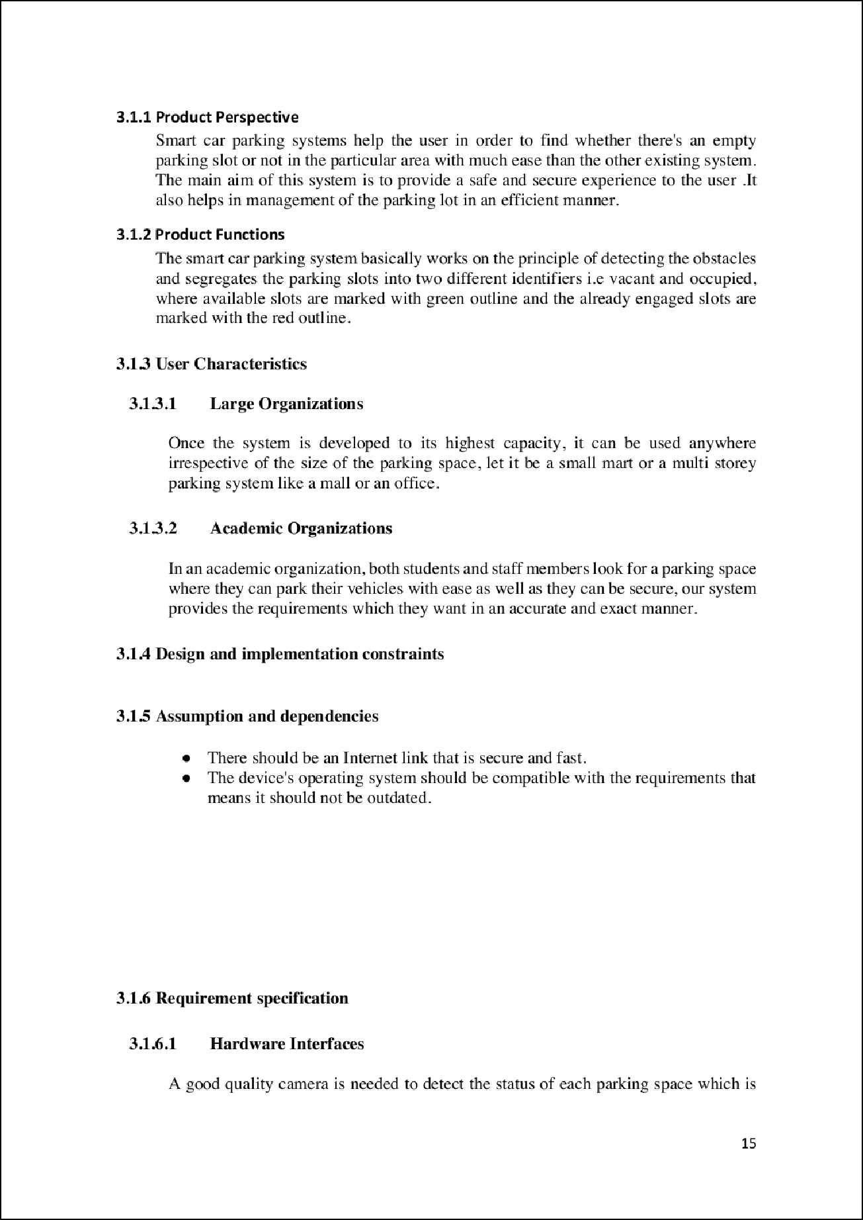

13

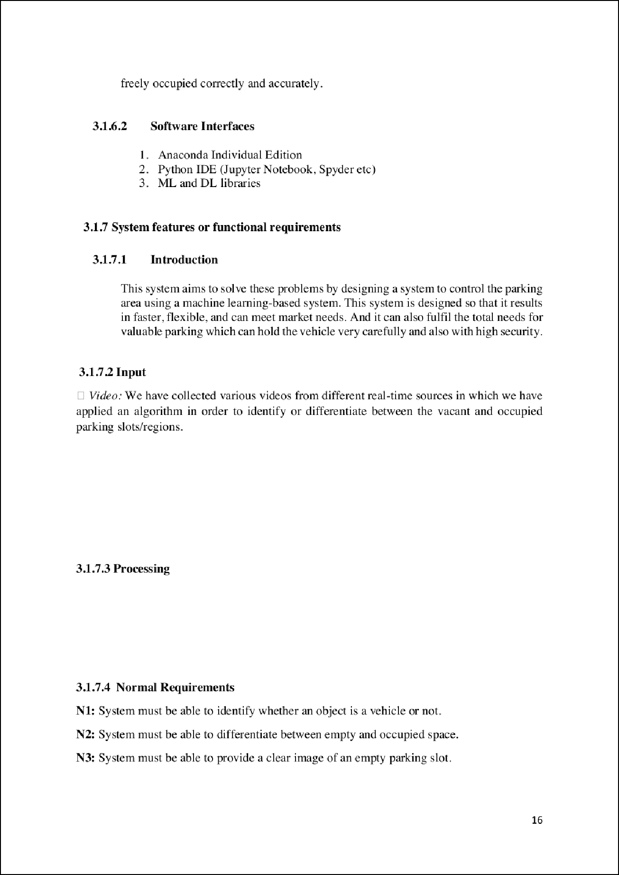

4

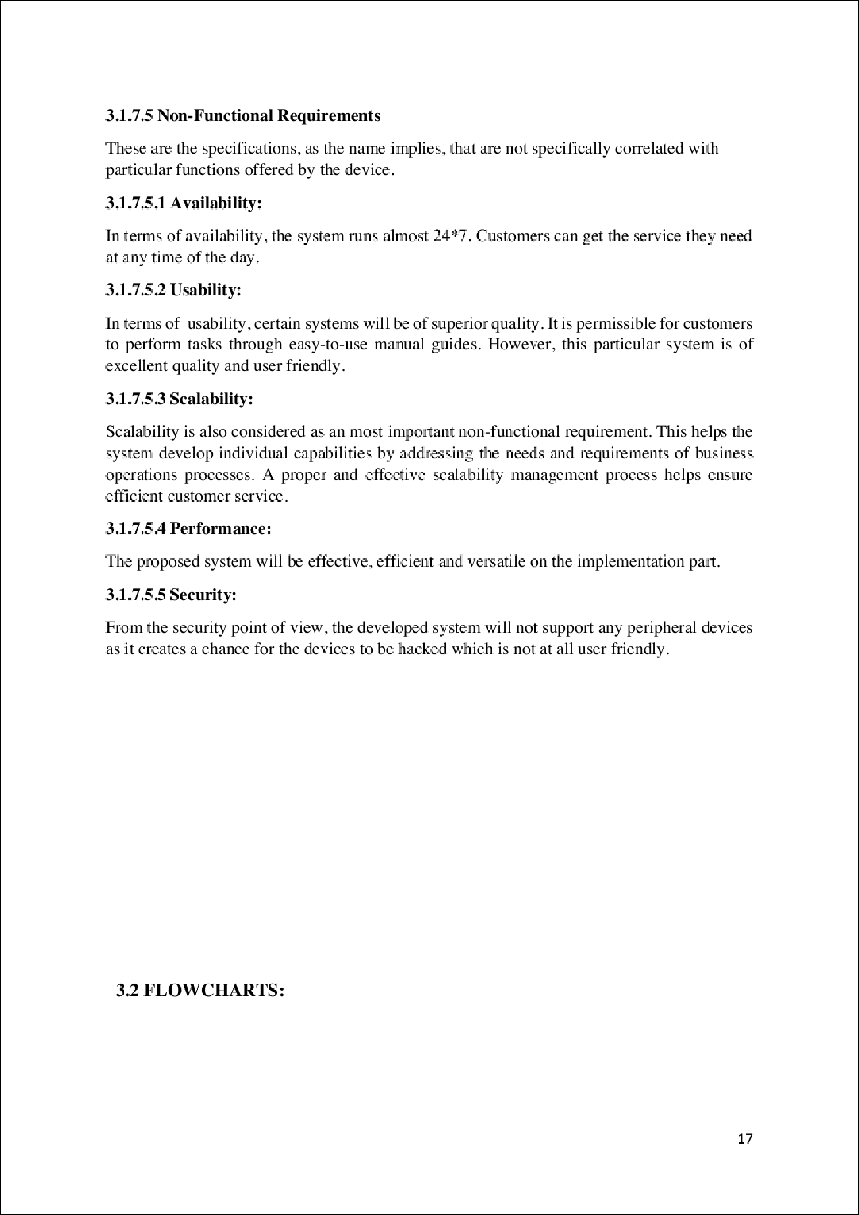

1

1

1

1

1

1

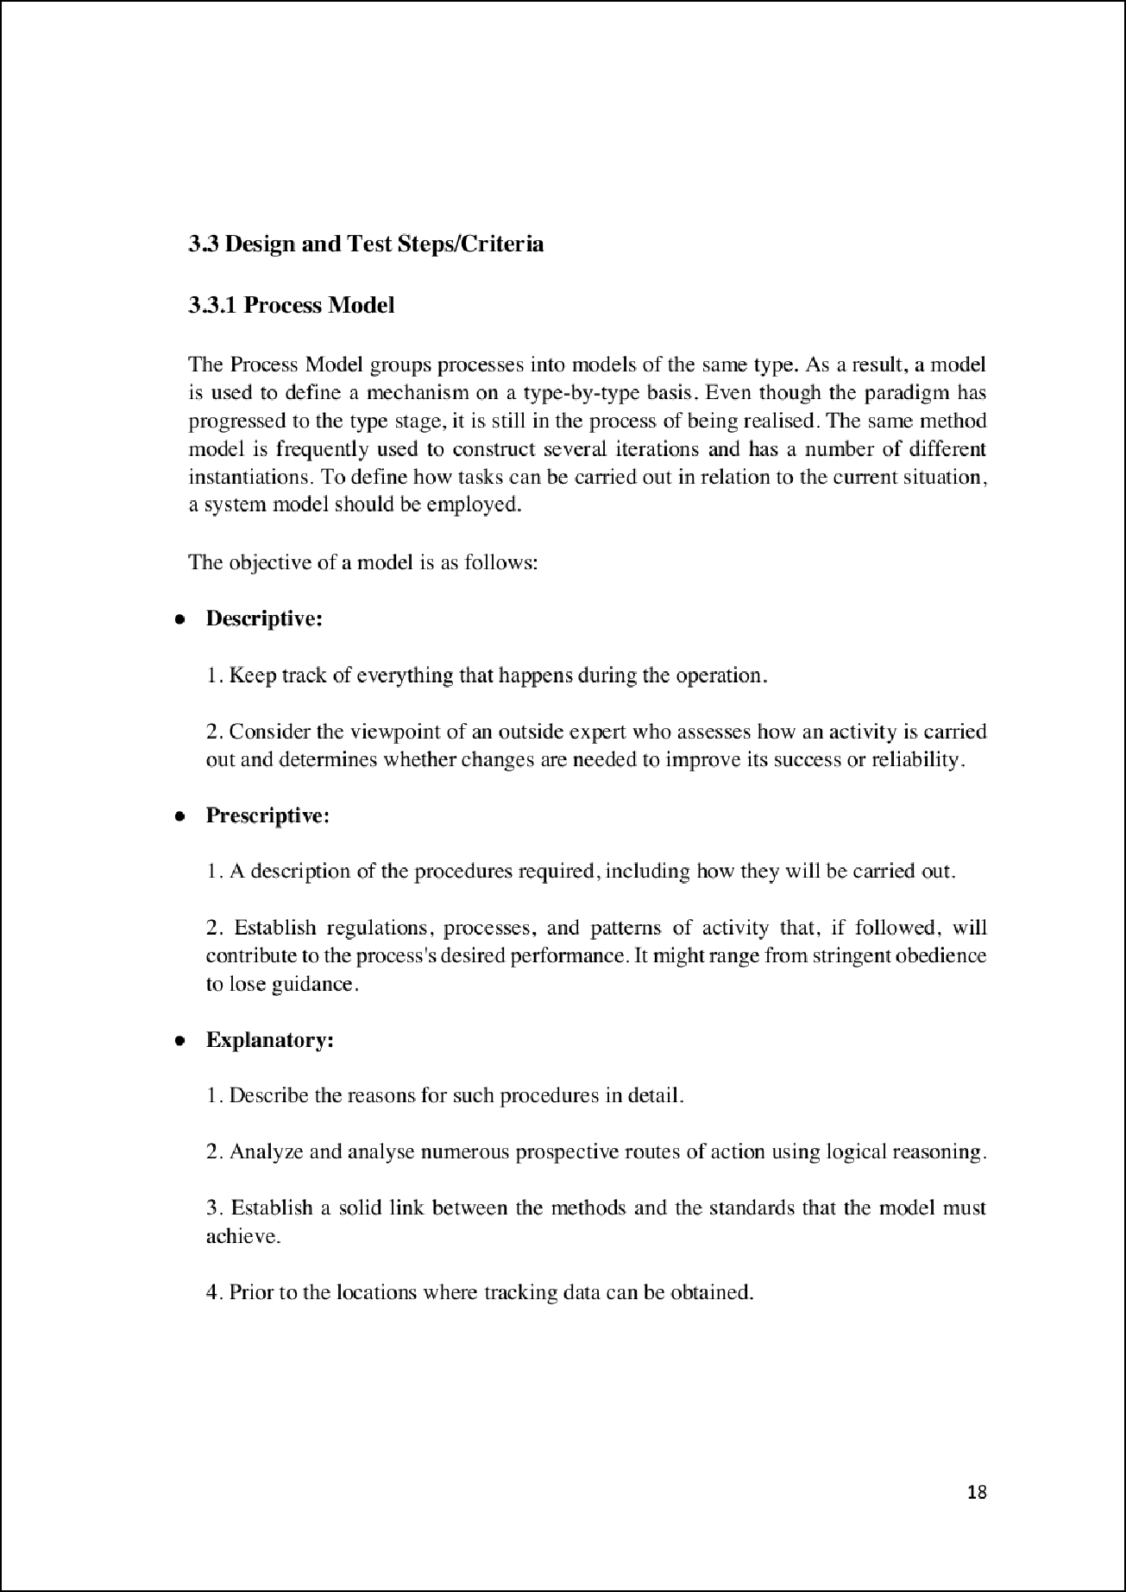

13

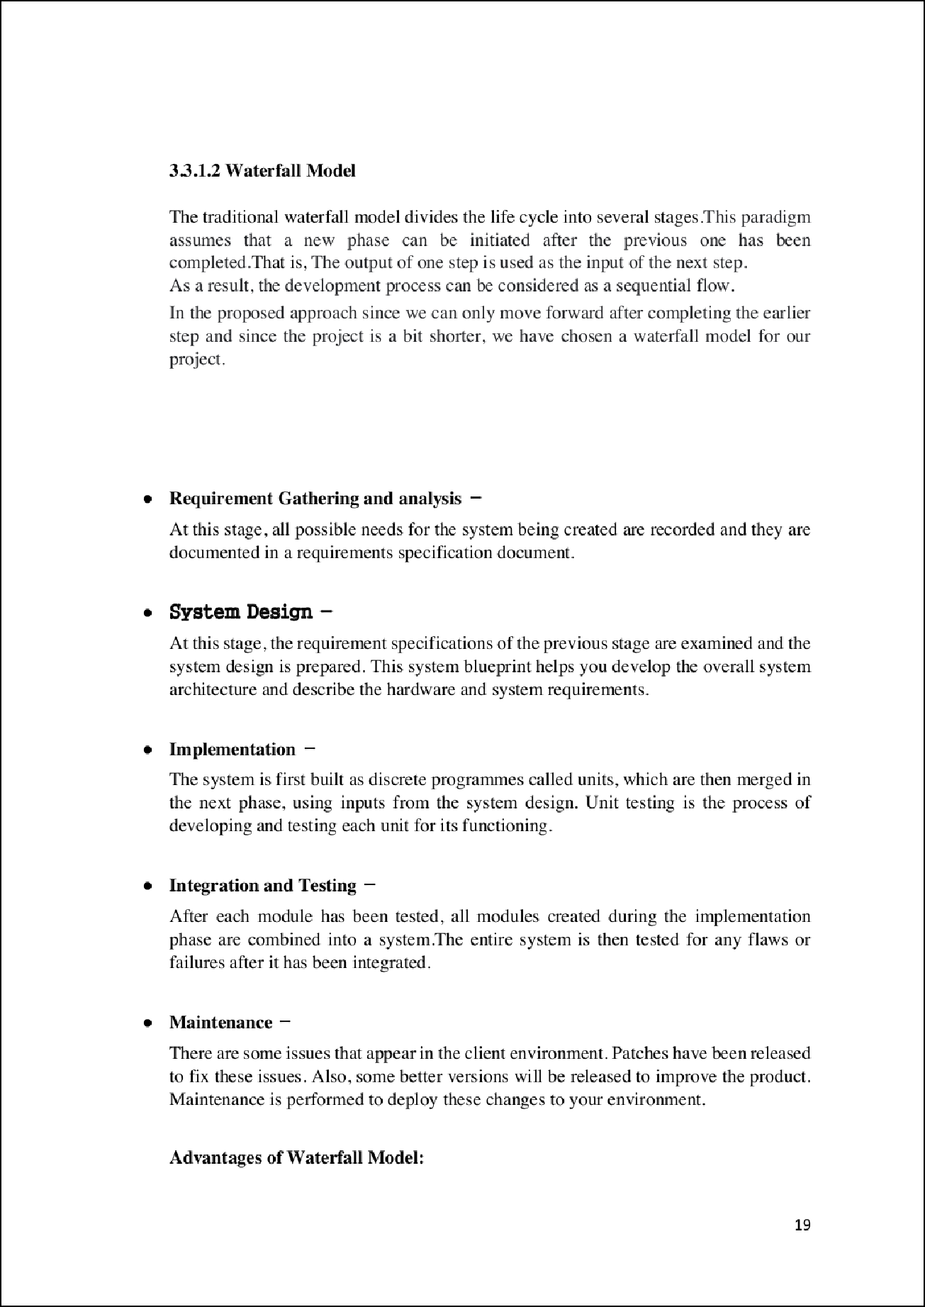

15

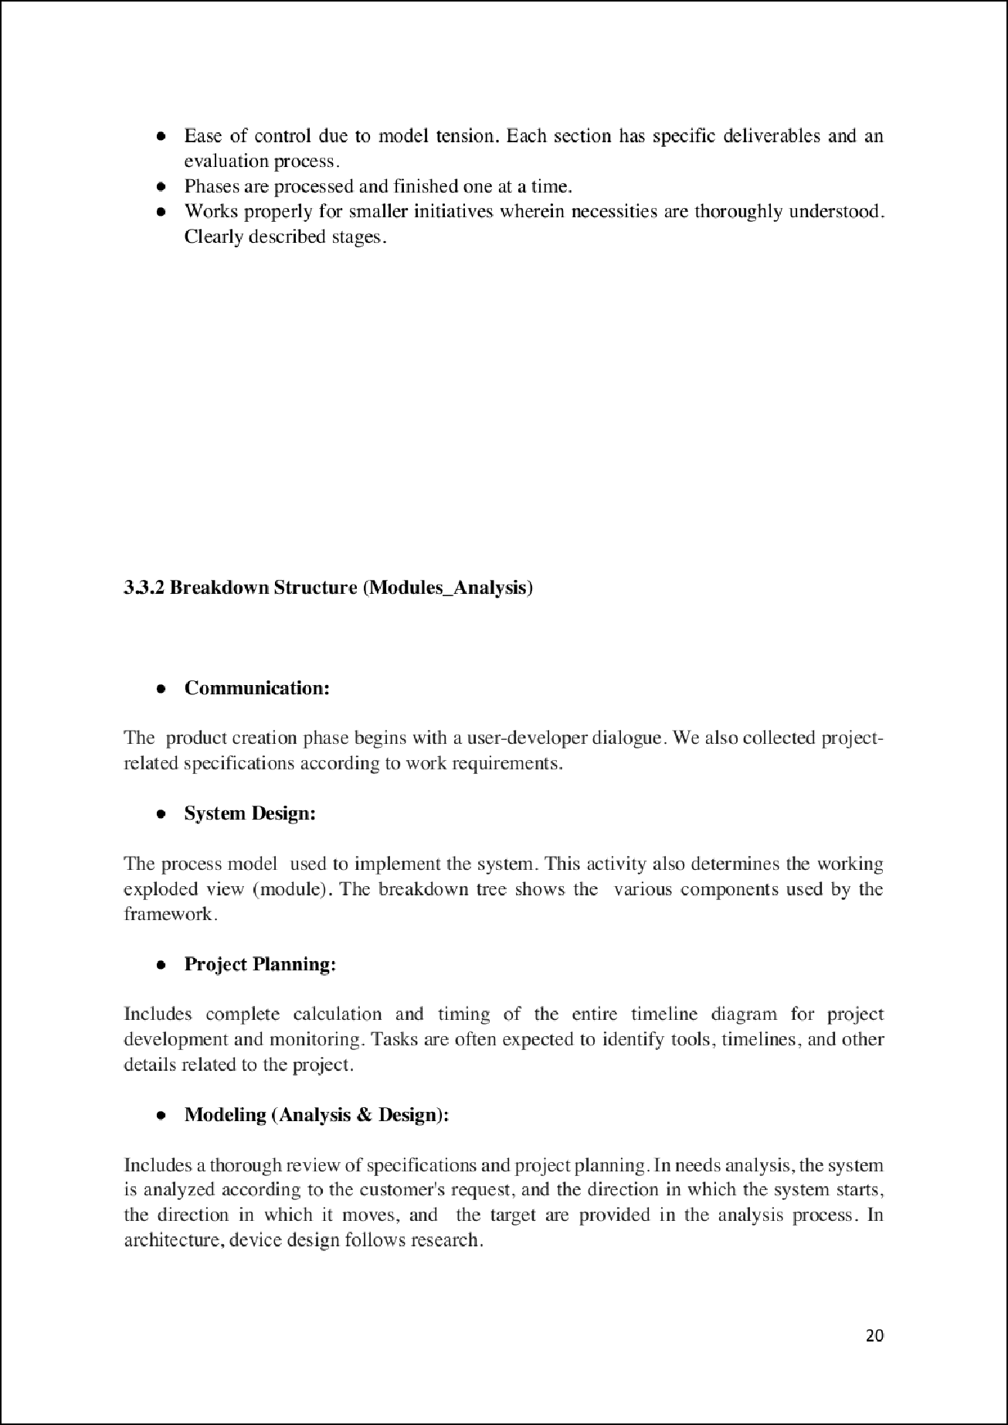

10

5



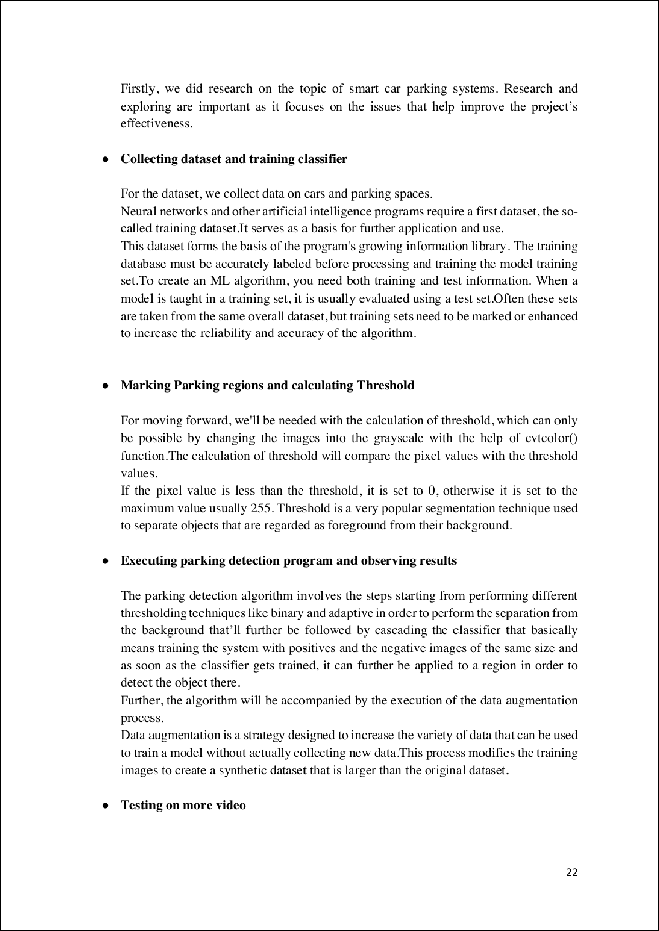

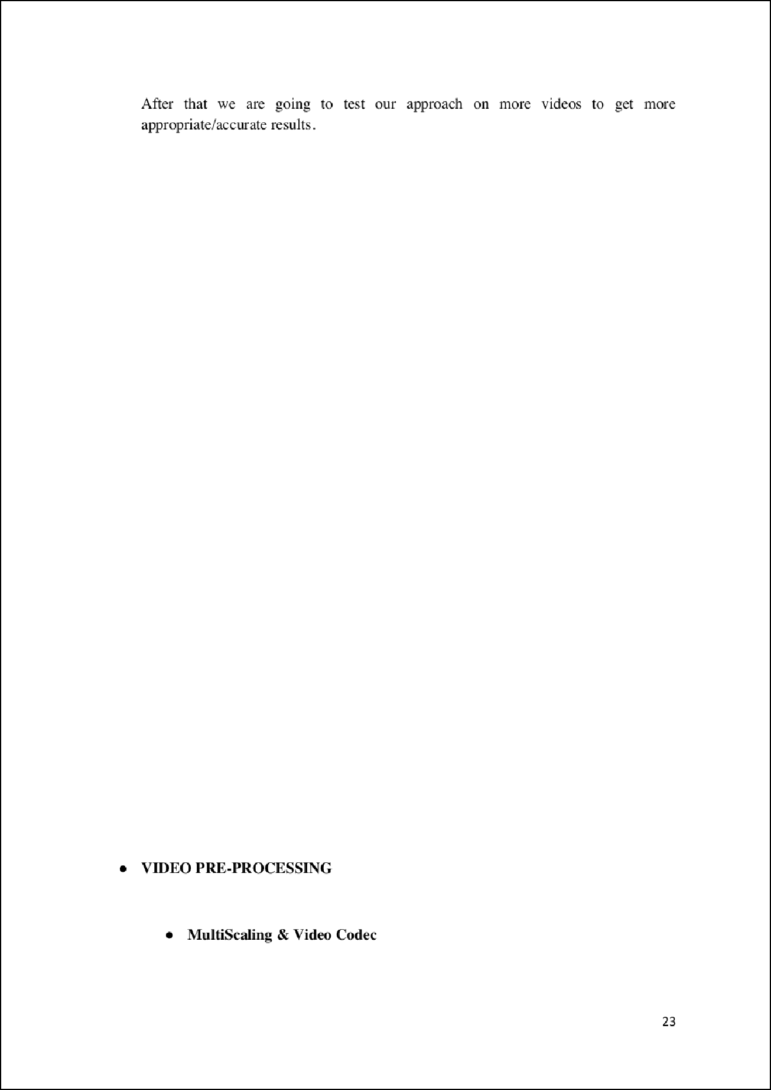

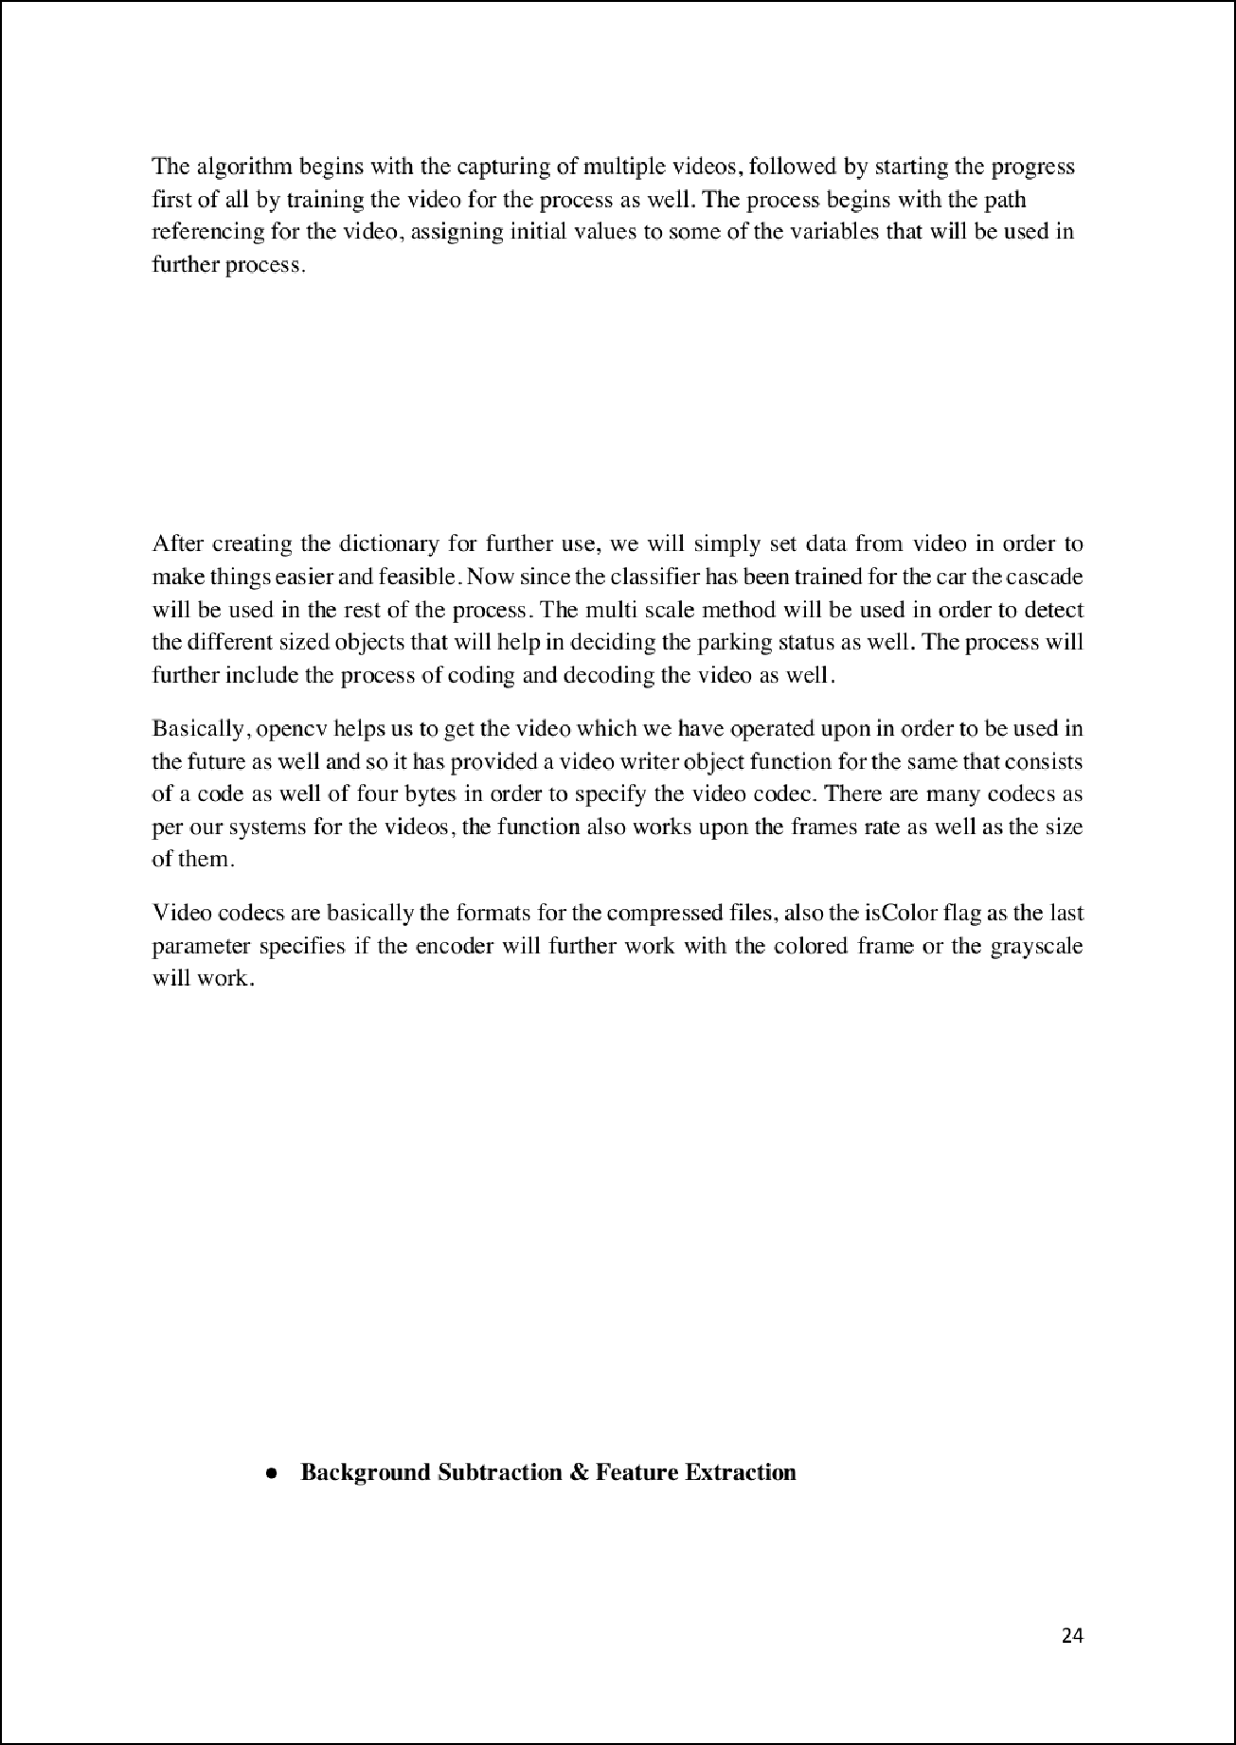

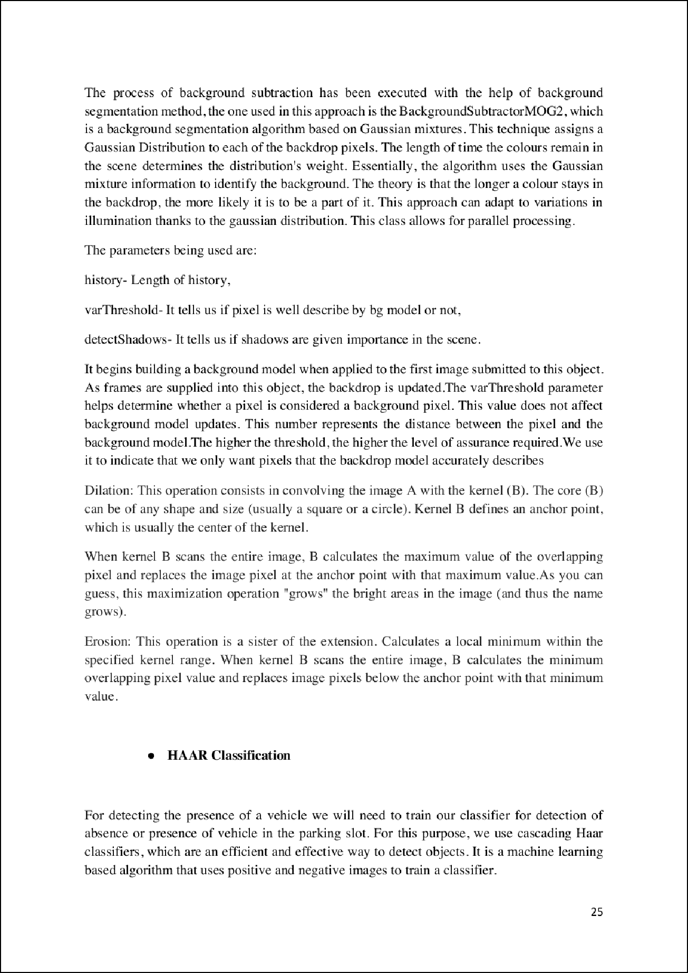

9

9

2

16

2

24

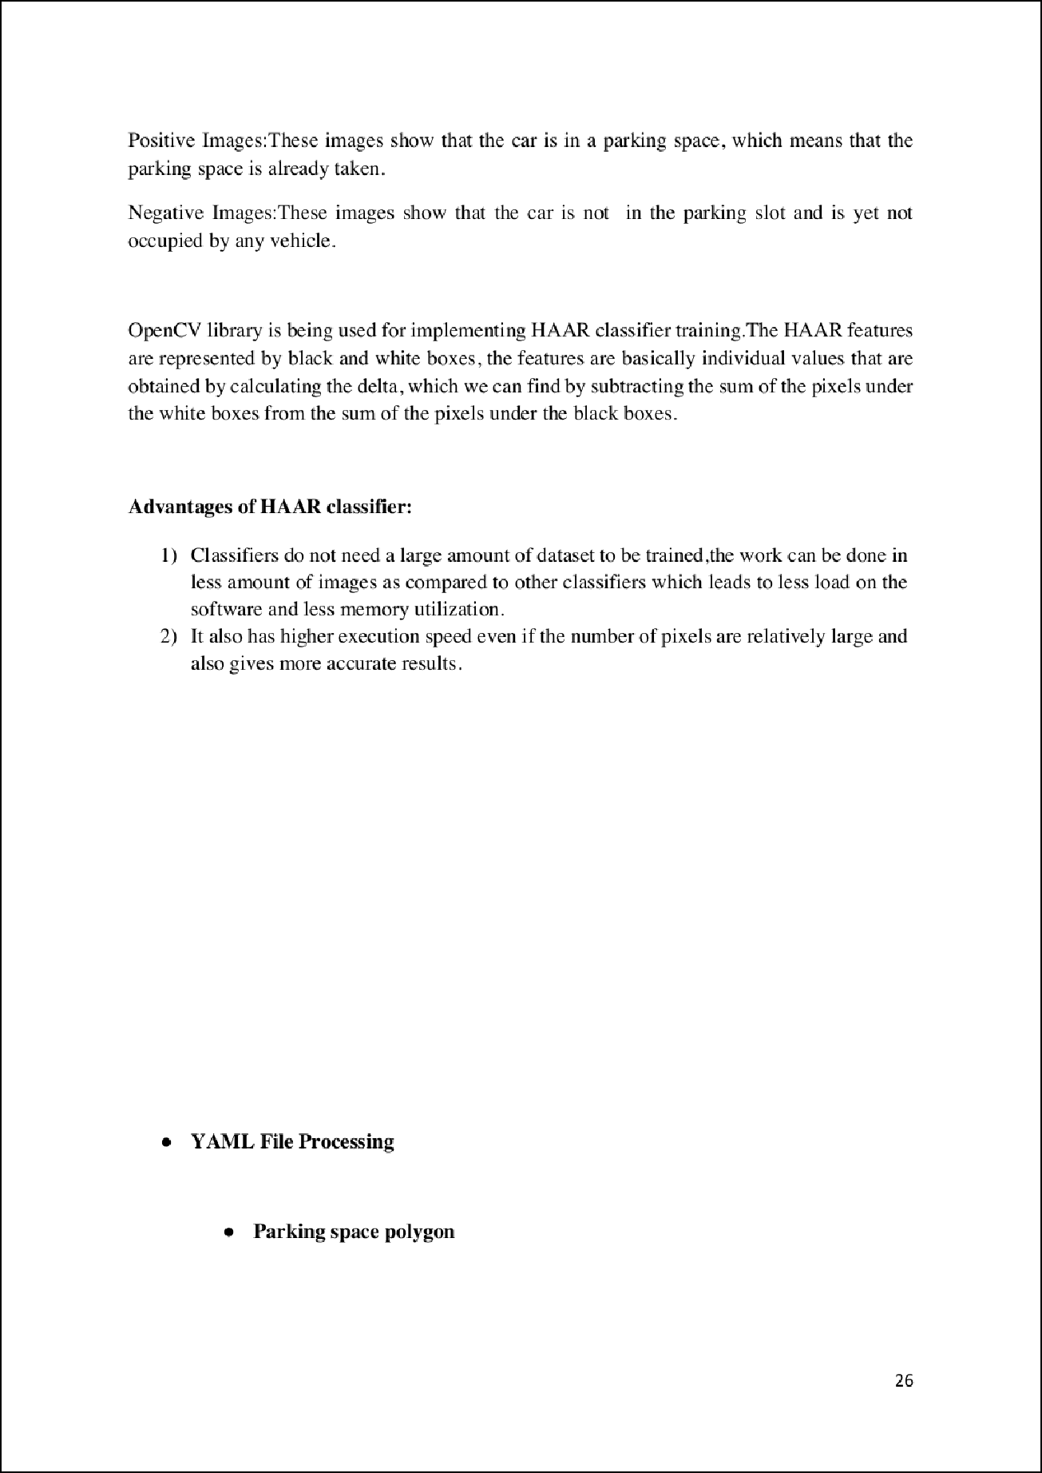

28

18

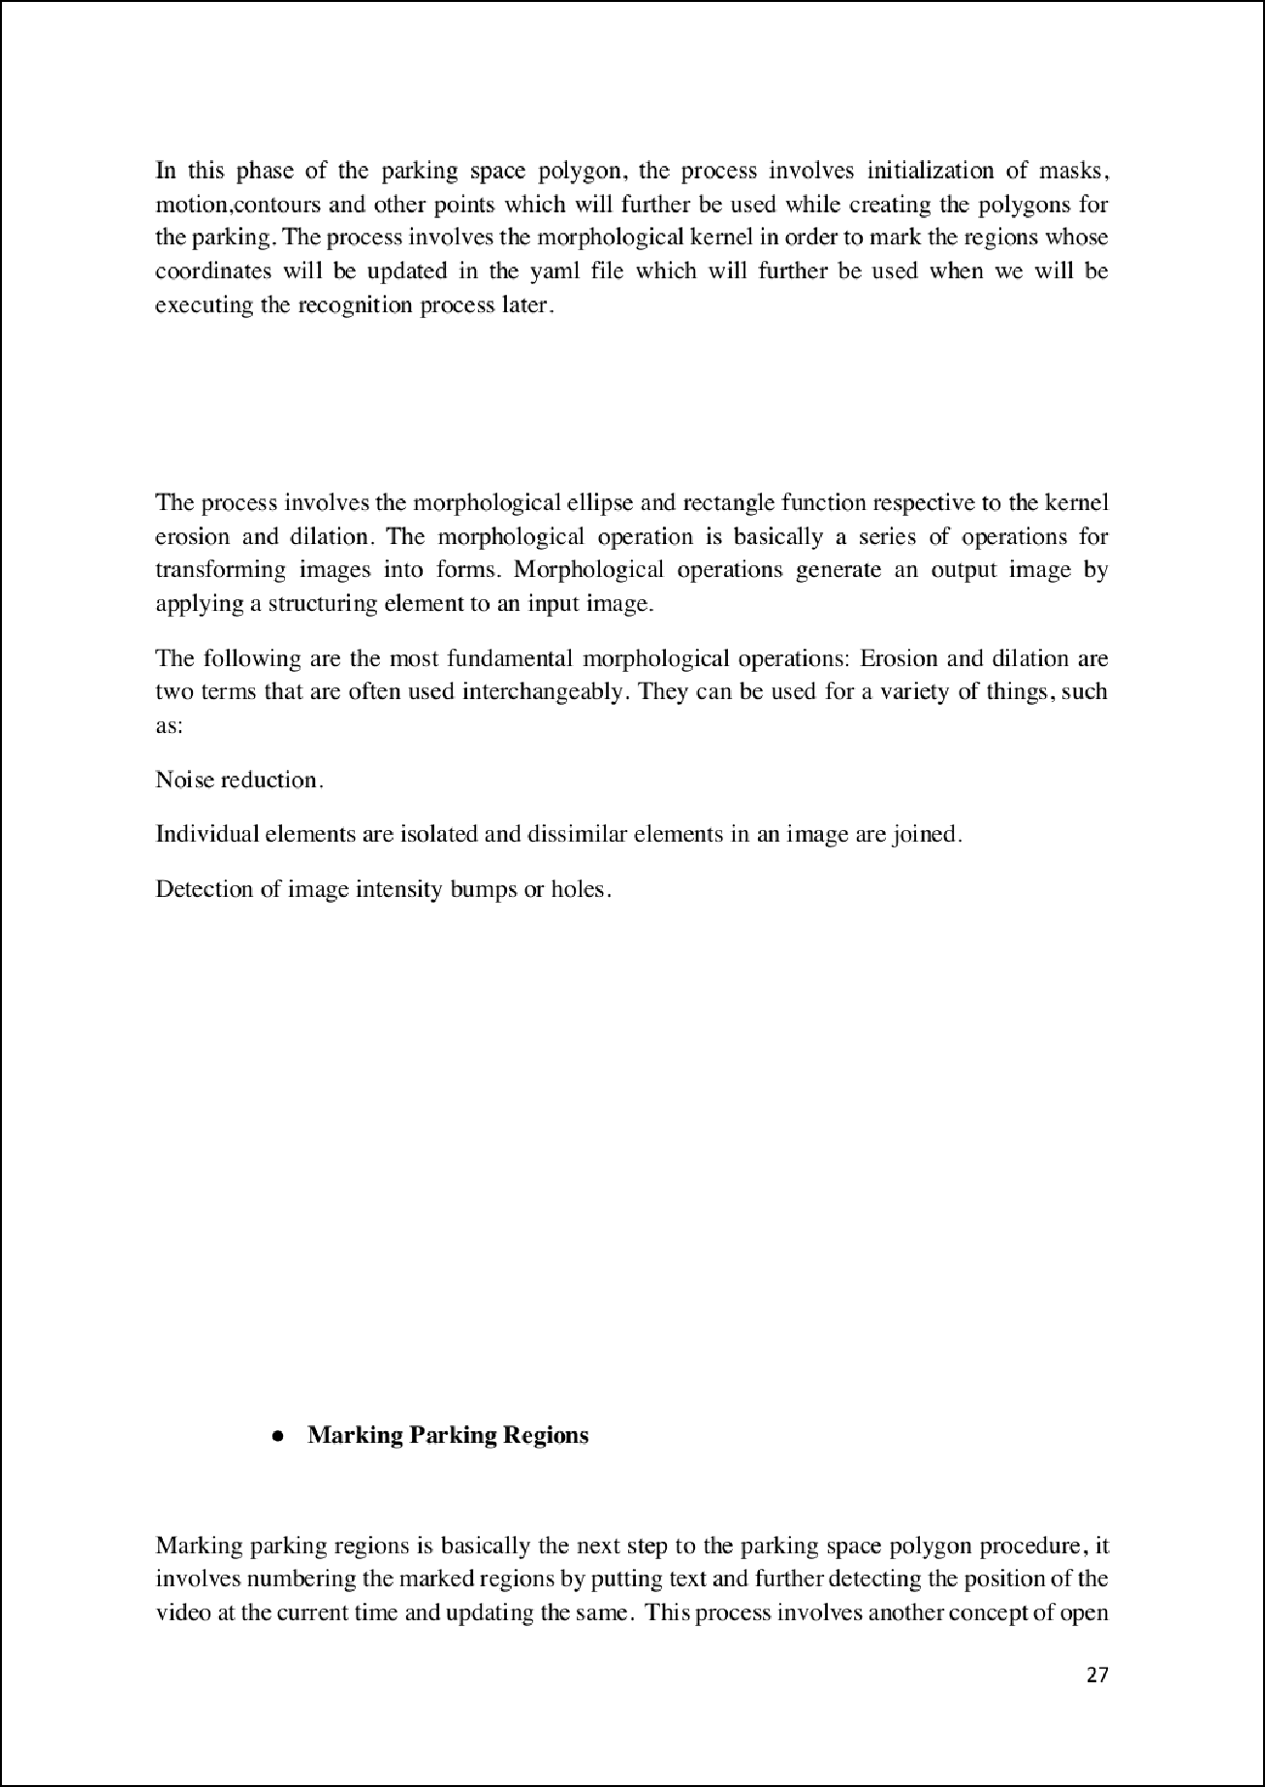

22

2

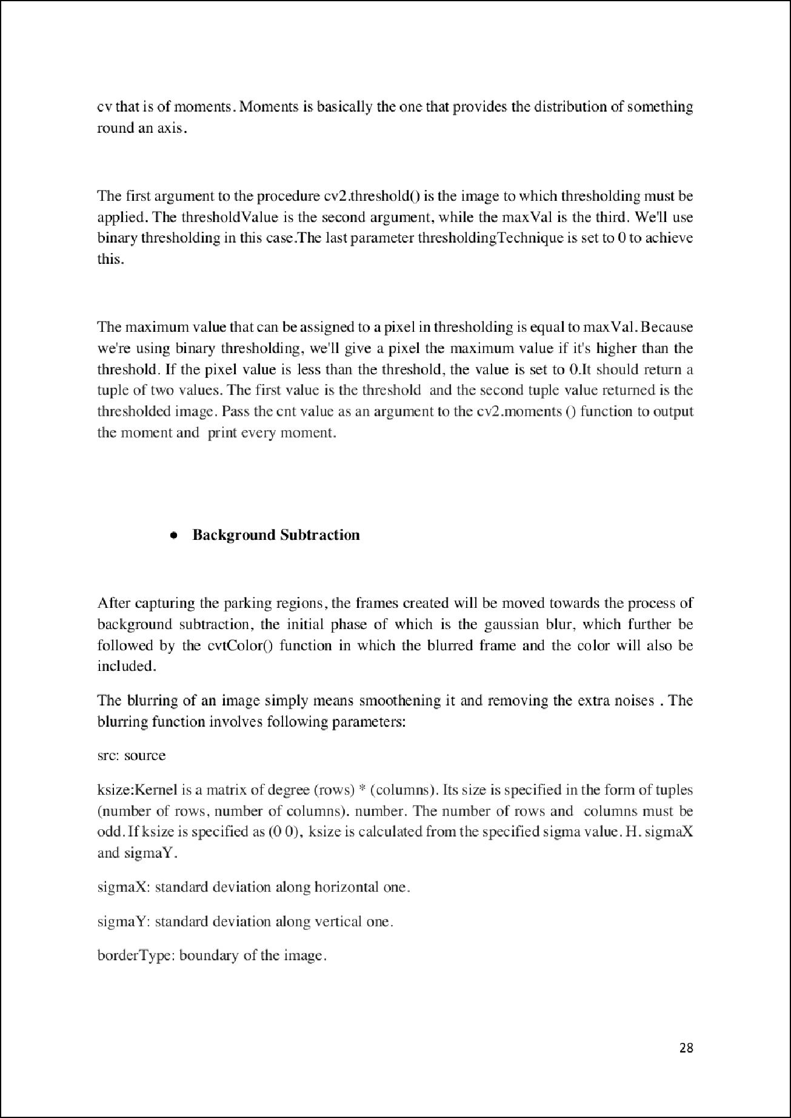

21



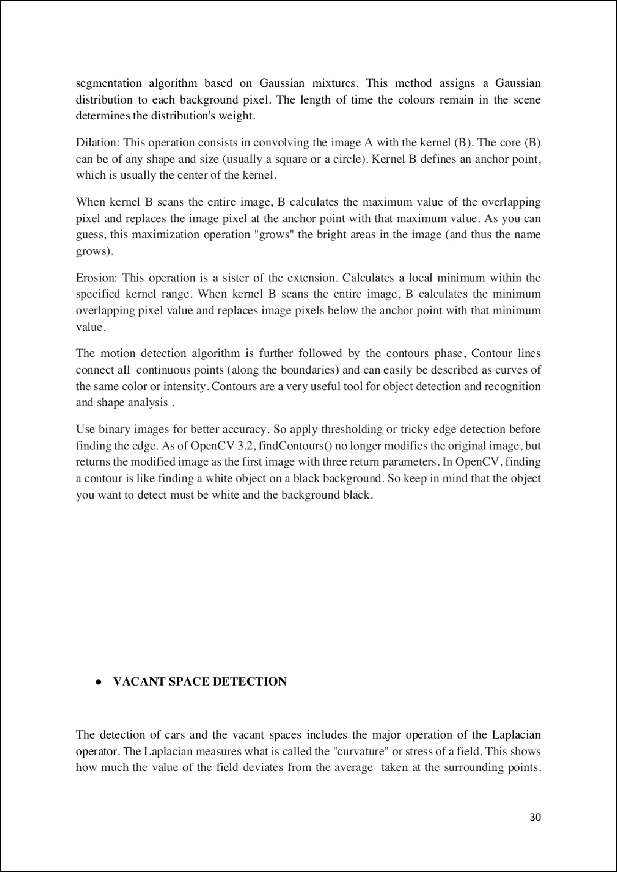

2

17

2

14

8

7

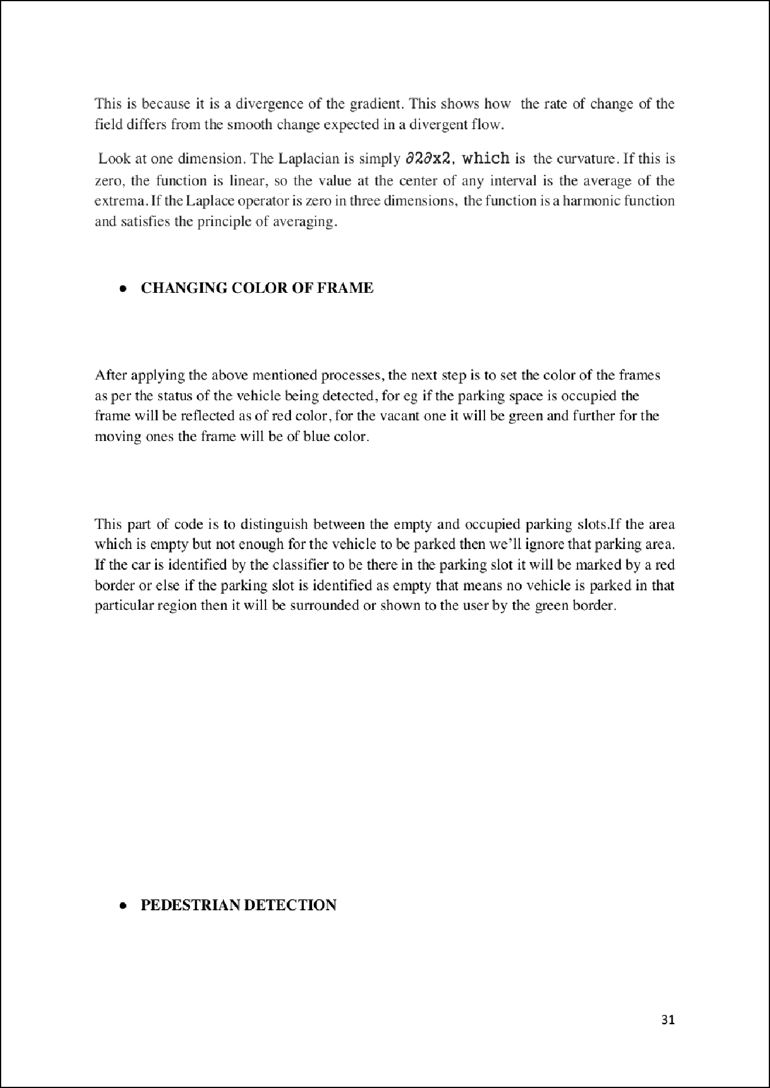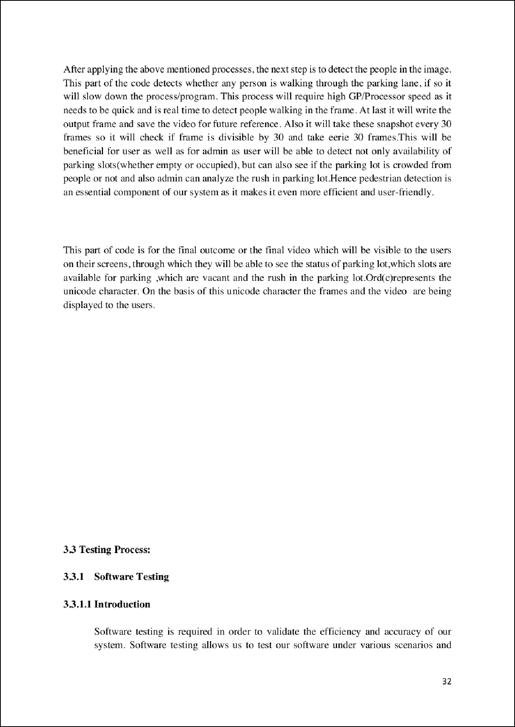

25

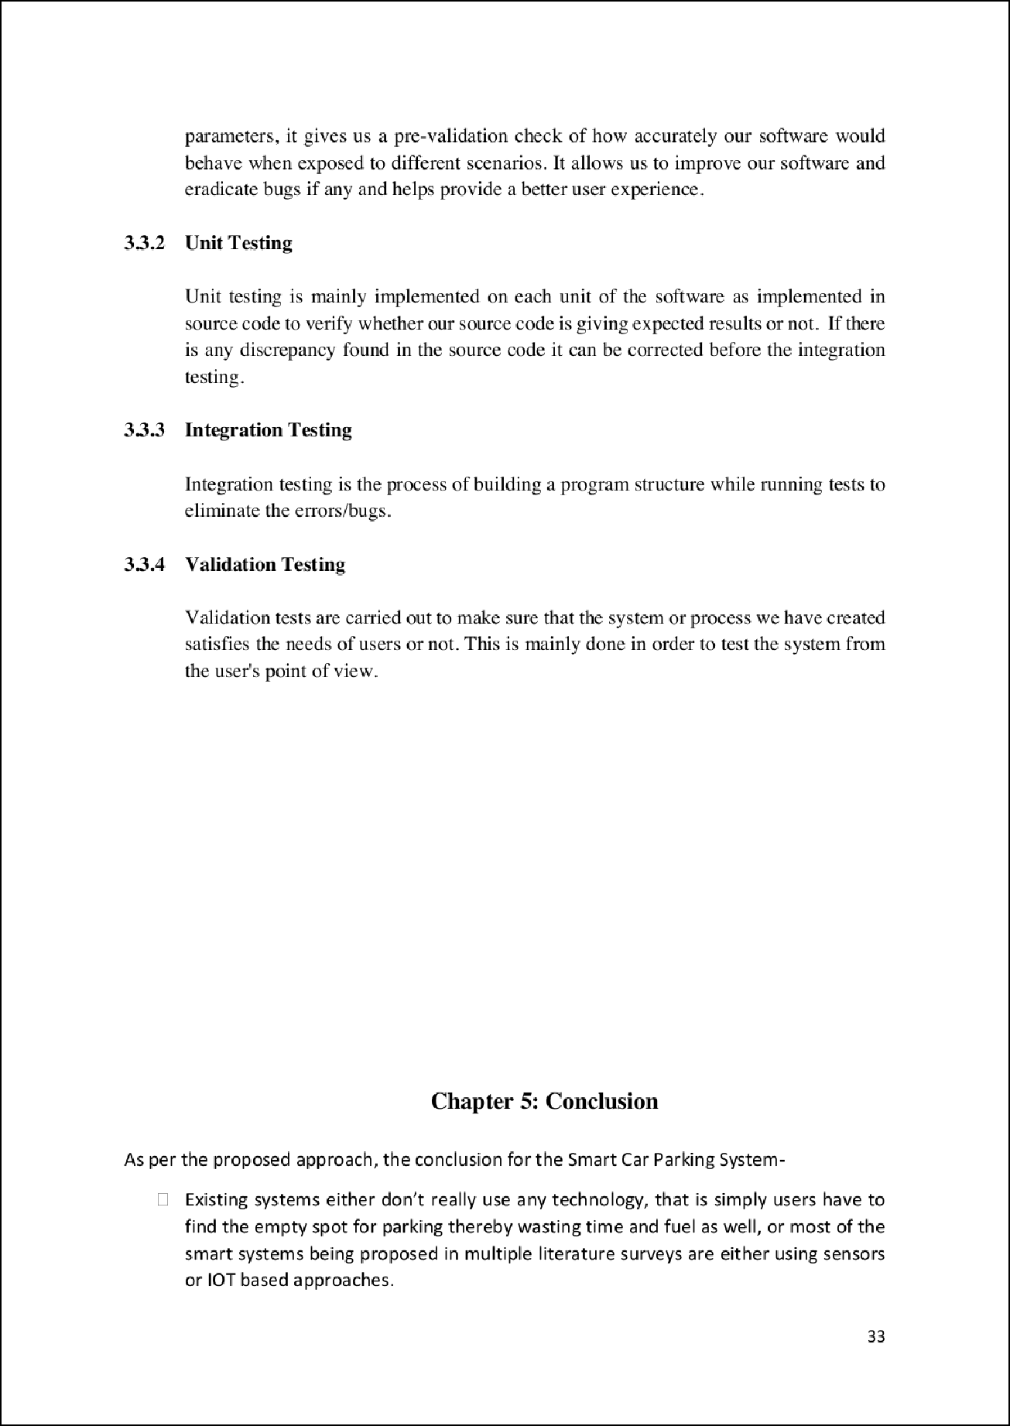

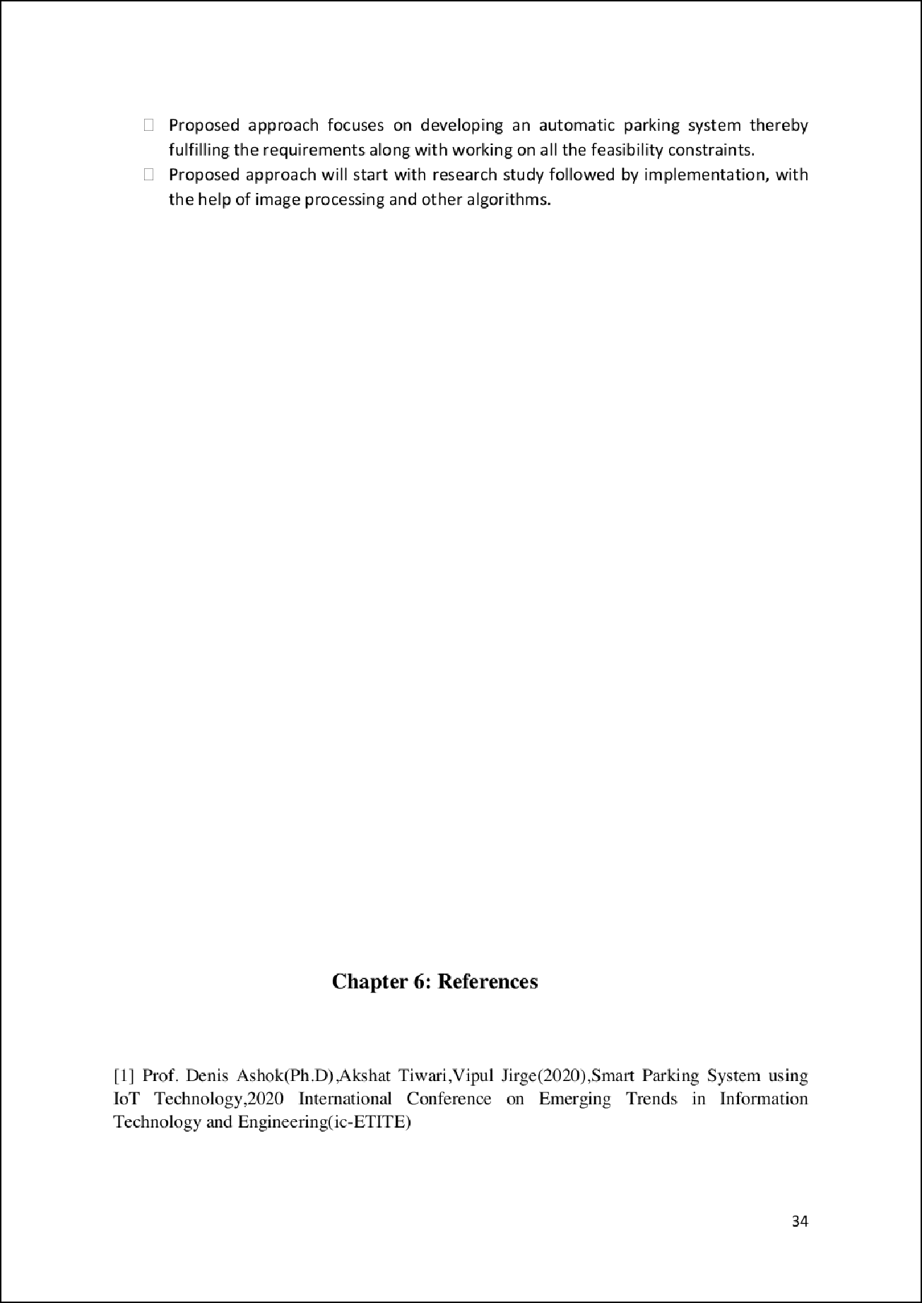

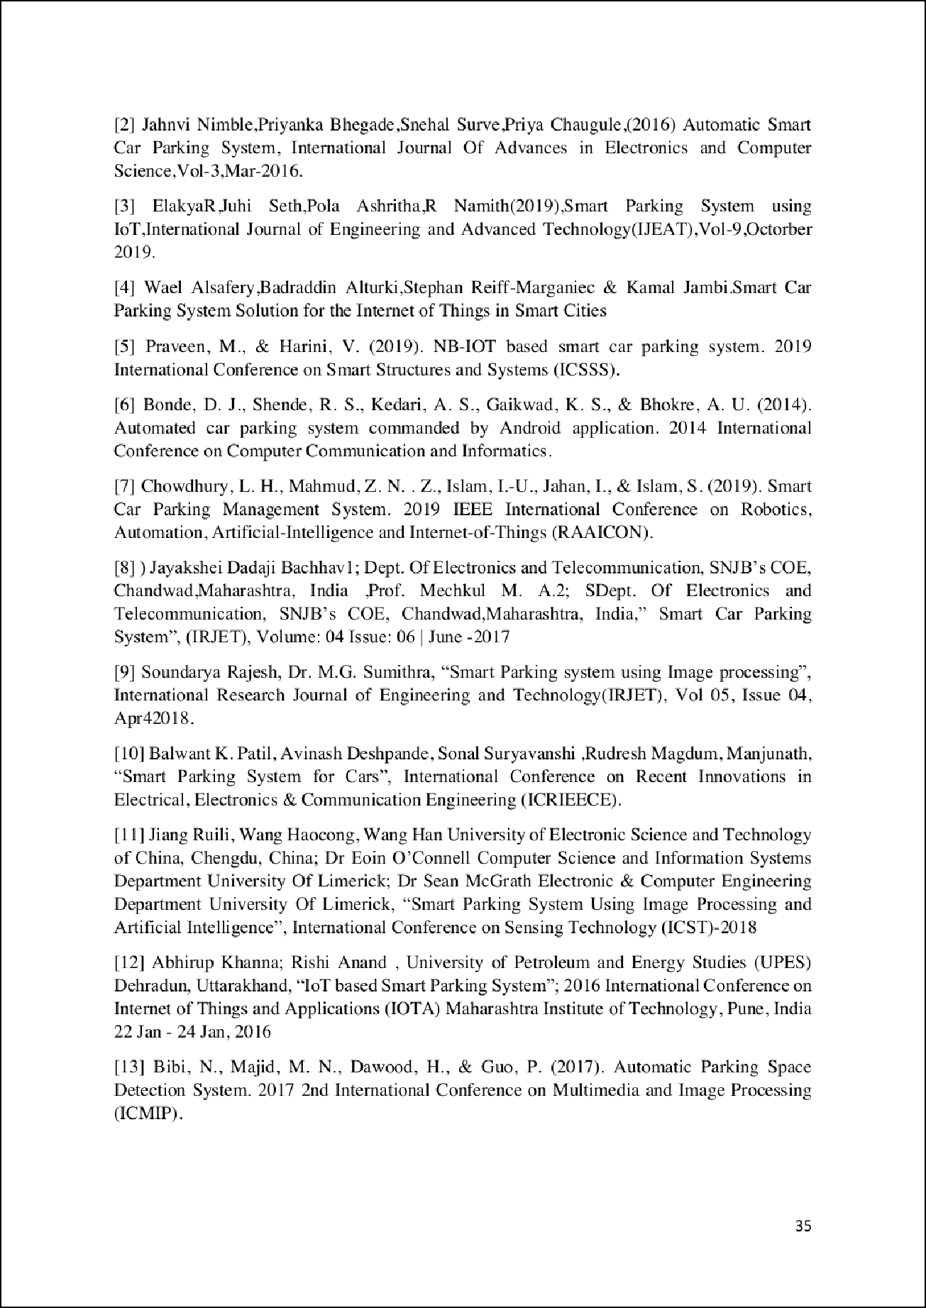

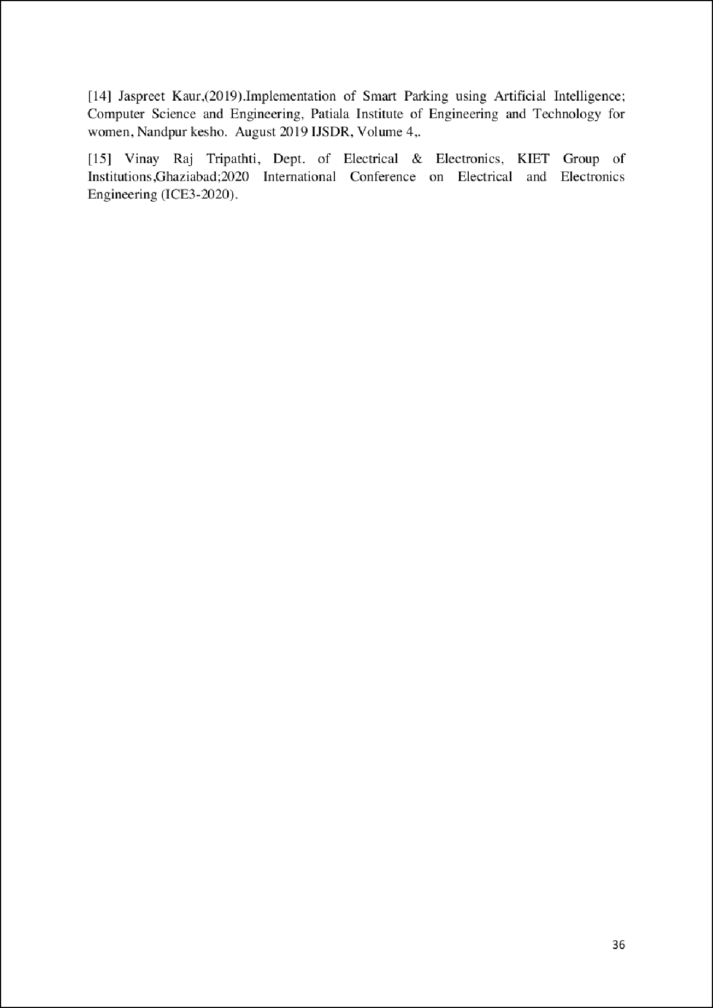

Chapter1: INTRODUCTION

12

ORIGINALITY REPORT

%

SIMILARITY INDEX

8%

INTERNET SOURCES

3%

PUBLICATIONS

8%

STUDENT PAPERS

PRIMARY SOURCES

[www.totalassignmenthelp.com](http://www.totalassignmenthelp.com/)

1

Internet Source

docs.opencv.org

2

Internet Source

towardsdatascience.com

3

Internet Source

Submitted to Amity University

4

Student Paper

Submitted to GIFT University

5

Student Paper

Submitted to Arab Open University

6

Student Paper

Submitted to University of Salford

7

Student Paper

Submitted to SRM University

8

Student Paper

Submitted to The University of Manchester

9

Student Paper

2%

1%

1%

1%

1%

1%

<1%

<1%

<1%

10

11

12

13

14

15

16

17

Submitted to NCC Education

Student Paper

Submitted to University of Wales Institute, Cardiﬀ

Student Paper

M.Z.M. Nasir, S. Salimin, B. Chan, S.A. Jumaat. "Prototype development of smart parking system powered by solar photovoltaic", Indonesian Journal of Electrical Engineering and Computer Science, 2020

Publication

[www.coursehero.com](http://www.coursehero.com/)

Internet Source

Submitted to Jawaharlal Nehru University (JNU)

Student Paper

Submitted to University of Greenwich

Student Paper

Submitted to University of Newcastle upon Tyne

Student Paper

Don Daven Christopher Trapal, Bryan Chia Chee Leong, Haw Wen Ng, John Tan Guan Zhong, Sutthiphong Srigrarom, Teng Hooi Chan. "Improvement of Vision-based Drone Detection and Tracking by Removing

<1%

<1%

<1%

<1%

<1%

<1%

<1%

<1%

18

19

20

21

22

23

24

25

26

27

Cluttered Background, Shadow and Water Reﬂection with Super Resolution", 2021 6th International Conference on Control and Robotics Engineering (ICCRE), 2021

Publication

Submitted to Harding University

Student Paper

ieeexplore.ieee.org

Internet Source

ijarcce.com

Internet Source

[www.mdpi.com](http://www.mdpi.com/)

Internet Source

d.researchbib.com

Internet Source

Submitted to Hoa Sen University

Student Paper

origin.geeksforgeeks.org

Internet Source

wiki.sugarlabs.org

Internet Source

hr.salkeiz.k12.or.us

Internet Source

M Meenaloshini, J Ilakkiya, P Sharmila, J.C Sheﬃ Malar, S Nithyasri. "Smart Car Parking

<1%

<1%

<1%

<1%

<1%

<1%

<1%

<1%

<1%

<1%

28

29

30

31

32

33

34

System in Smart Cities using IR", 2019 3rd International Conference on Computing and Communications Technologies (ICCCT), 2019

Publication

ebin.pub

Internet Source

ijsart.com

Internet Source

Alice May-Kuen Wong, Chien-Lung Hsu, Tuan- Vinh Le, Mei-Chen Hsieh, Tzu-Wei Lin. "Three- Factor Fast Authentication Scheme with Time Bound and User Anonymity for Multi-Server E-Health Systems in 5G-Based Wireless Sensor Networks", Sensors, 2020

Publication

ijarcet.org

Internet Source

[www.ijert.org](http://www.ijert.org/)

Internet Source

[www.researchgate.net](http://www.researchgate.net/)

Internet Source

[www.slideshare.net](http://www.slideshare.net/)

Internet Source

<1%

<1%

<1%

<1%

<1%

<1%

<1%

Exclude quotes On Exclude bibliography On

Exclude matches Oﬀ